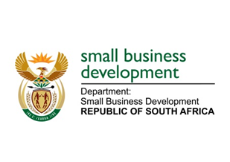
NATIONAL ASSEMBLY
QUESTION FOR WRITTEN REPLY
DUE TO PARLIAMENT: FRIDAY, 9 JUNE 2023

“2003. Ms B Mathulelwa (EFF) to ask the Minister of Small Business Development:
What recent interventions has she put in place to combat the rising trends of corruption in the Small Enterprise Finance Agency that are witnessed across the Republic?” NW2264E

REPLY:
I am advised as follows:

The Small Enterprise Finance Agency (sefa) takes fraud and corruption seriously. There are various mechanisms and strategies developed by (sefa) to inwardly address potential risk of fraudulent activities. One of these is the anti-fraud hotline at sefa with contact number 0800 000 663. Instances where corruption and fraud has been reported Sefa has instituted investigations and will act on the recommendations where our officials might have been involved.

