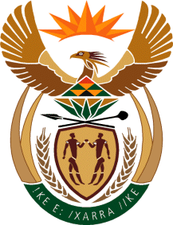

MINISTRY: COMMUNICATIONS
REPUBLIC OF SOUTH AFRICA
Private Bag X 745, Pretoria, 0001, Tel: +27 12 473 0164 Fax: +27 12 473 0585
Tshedimosetso House,1035 Francis Baard Street, Tshedimosetso House, Pretoria, 1000

NATIONAL ASSEMBLY
QUESTION FOR WRITTEN REPLY
QUESTION NUMBER: 2002
DATE OF PUBLICATION: 23 SEPTEMBER 2016

Ms P T van Damme (DA) to ask the Minister of Communications:
Whether the SA Broadcasting Corporation (SABC) sought any (a) sponsorships and/or (b) partnerships to support the Thank You SABC Music Concert held on 10 September 2016 at the Orlando Stadium; if not, what is the position in this regard; if so, what is the detailed breakdown of the (i) names of the sponsors and/or partners and (ii) value of the sponsorship and/or partnership received in each case? NW2313E
REPLY: MINISTER OF COMMUNICATIONS
The sponsorships and/or partnerships to support the Thank You SABC music concerts would have been sought by Phumelela Group as the organiser of the event.

MR NN MUNZHELELE
DIRECTOR GENERAL [ACTING]
DEPARTMENT OF COMMUNICATIONS
DATE:

MS AF MUTHAMBI (MP)
MINISTER OF COMMUNICATIONS
DATE:

