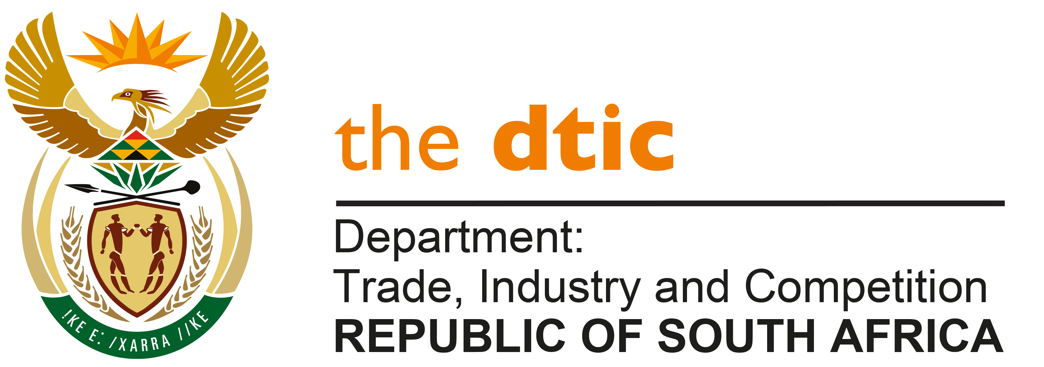

THE NATIONAL ASSEMBLY

QUESTION FOR WRITTEN REPLY

QUESTION NO: 2001
DATE PUBLISHED: 20 MAY 2022

Inkosi R N Cebekhulu (IFP) to ask the Minister of Trade, Industry and Competition:
What (a) has his department identified as the biggest stumbling block in finalising legislative changes that aim to narrow the earnings gap between company executives and the lowest paid workers and (b) is the progress report on this from the perspective of his department? [NW2343E]

REPLY:

First, proposals to address a broad public policy on dealing with wage gaps in industry, were developed and drafted into legislation, in the form of a Companies Amendment Bill, 2021 (the Bill)

Second, these proposals were discussed with social partners in Nedlac, where the principle of disclosure of the wage gaps and responsibilities assigned to shareholders, were agreed

Third, Cabinet was briefed on the proposed changes

Fourth, the proposals were published for public comment.

The public comments are currently being considered and in the Department’s Budget Vote this year, I indicated that the anticipated timeframe for the Bill be submitted to Cabinet for consideration, which is within the next three months.

-END-

