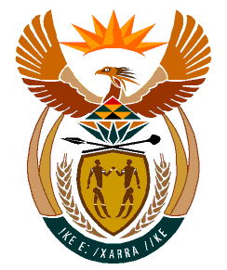

MINISTRY:
HUMAN SETTLEMENTS, WATER AND SANITATION
REPUBLIC OF SOUTH AFRICA

NATIONAL ASSEMBLY

QUESTION FOR WRITTEN REPLY

QUESTION NO.: 200

DATE OF PUBLICATION: 28 FEBRUARY 2020

Mr A M Shaik Emam (NFP) to ask the Minister of Human Settlements, Water and Sanitation:
Whether, in light of the fact that the President, Mr M C Ramaphosa, announced the establishment of the Human Settlements Development Bank during the State of the Nation Address on 7 February 2019, there has been any progress in the establishment of the specified bank; if not, what is the position in this regard; if so, what are the relevant details? NW130E

REPLY:

The Department has finalised the drafting of the Human Settlements Development Bank Bill including the business case on the establishment of the Bank. The Department is currently in consultation with the relevant stakeholders including, but not limited to, the National Treasury and the State Law Advisors before requesting Cabinet’s approval to publish the Bill for public comments.

