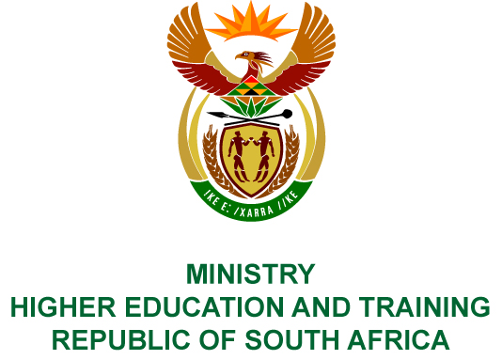
Private Bag X893, Pretoria, 0001, Tel (012) 312 5555, Fax (012) 323 5618
Private Bag X9192, Cape Town, 8000, Tel (021) 469 5150, Fax: (021) 465 7956
Memorandum from the Parliamentary Office
NATIONAL ASSEMBLY
FOR WRITTEN REPLY
QUESTION 200
DATE OF PUBLICATION OF INTERNAL QUESTION PAPER: 08/02/2018

(INTERNAL QUESTION PAPER NO 1 OF 2018)
Mrs E N Ntlangwini (EFF) to ask the Minister of Higher Education and Training:
Did the National Institute for the Humanities and Social Sciences use the services of a certain company (name furnished) on 1 July 2017; if not, what is the position in this regard; if so, (a) what number of (i) shuttles were used and (ii) persons were transported, (b) where were the specified persons transported to, (c) what was the amount on the invoice issued by the specified company, (d) was the service provided by the company the cheapest travel option taken, (e) did the spending comply with the cost cutting measures and regulations of (i) the National Treasury, (ii) her department and (iii) the Auditor-General of South Africa and (f) who approved the trip and payment?
NW208E

REPLY:
The National Institute for Humanities and Social Sciences has provided the following response to the questions posed.
The services of Exclusive Travel Tours was not used on 1 July 2017.

COMPILER DETAILS
NAME AND SURNAME: MS PEARL WHITTLE
CONTACT: 012 312 5248
RECOMMENDATION
It is recommended that the Minister signs Parliamentary Question 200.

MR GF QONDE
DIRECTOR–GENERAL: HIGHER EDUCATION AND TRAINING
DATE:

PARLIAMENTARY QUESTION 200 IS APPROVED / NOT APPROVED / AMENDED.
COMMENT/S

PROF HB MKHIZE, MP
MINISTER OF HIGHER EDUCATION AND TRAINING
DATE:

