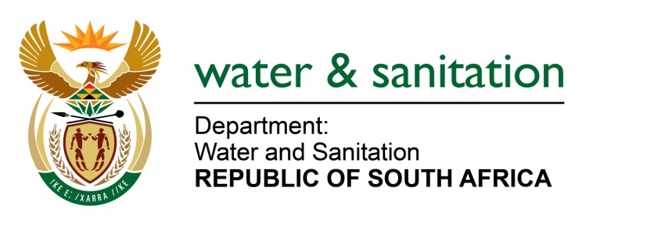

NATIONAL ASSEMBLY

FOR WRITTEN REPLY

QUESTION NO 1999

DATE OF PUBLICATION IN INTERNAL QUESTION PAPER:
(INTERNAL QUESTION PAPER NO. 19) 26 MAY 2023

1999. Mrs M R Mohlala (EFF) to ask the Minister of Water and Sanitation:
Whether he has been informed that the uGu District Municipality in KwaZulu-Natal has failed to deliver water to the residents of the specified municipality for approximately one month, thereby exacerbating an ongoing water crisis that has persisted for over two years; if not, what is the position in this regard; if so, what (a) are the reasons that the municipality has failed to deliver water to its residents, thereby exacerbating a two year-long water crisis, (b) measures have been taken by his department to handle the water crisis in the past and (c) long-term (i) strategies and (ii) plans does his department have in place to prevent such recurring problems and ensure a reliable supply of clean and potable water to the residents?
NW2258E
---00O00---

MINISTER OF WATER AND SANITATION
- Over the past few years, the Ugu DM has experienced significant water supply challenges throughout the district due to several challenges outlined in the table below:
- The current operational treatment capacity of the Ugu DM WSA (excluding boreholes) is approx. 130 Ml/day. The 2020 water demand model indicates a current water demand of approximately 200 Ml/day (immediate 70 Ml/day shortfall) and a future predicted (2050) water demand of approx. 330 Ml/day. Water supply shortages are exacerbated during the peak holiday periods when demand often doubles.
- Due to shortage of bulk water and bulk storage capacity any interruptions in supply from bursts, equipment failures, leaks and power outages result in the systems emptying rapidly and systems destabilising and resulting in water interruptions. Due to demand outstripping supply, systems can take extensive periods to stabilize.
- There are staff disputes and ongoing vandalism.
- Damage to assets and infrastructure during the July 2021 unrest.
- Problems with the billing system, revenue collection and dissatisfaction with service have reduced revenue and sustainability of service.
- Illegal connections resulting in water losses, reduce revenue and demands on systems.

- The Department of Water and Sanitation (DWS) has been actively participating in different structures and the inter-Ministerial Task Team and other structures established by the Premier of KwaZulu-Natal in January 2022. The participants include the Planning Commission, Municipal Infrastructure Support Agent (MISA), DWS, Provincial Department of Cooperative Governance and Traditional Affairs (CoGTA).

The Task Team was intended to determine the root causes of water supply interruptions in the various supply systems in the municipality and develop actionable interventions. In addition, the Minister of Water and Sanitation established a WAR room in November 2022 to monitor the progress made with implementation of the interventions being implemented in the area.

In line with its mandate, the DWS has focused support to ensure availability of sufficient water resources to supply the area. The Minister issued a Directive to Umgeni Water to fund and implement the Cwabeni Dam, an off channel storage dam with a capacity of approximately 70 million cubic meters to augment the Bhobhoi/ uMzimkhulu supply system which feeds Port Shepstone and surrounding areas. This project will increase the yield of the raw water supply system and reduce the risk of non-supply during dry periods.

The DWS is also supporting the Ugu DM with the detailed planning for other regional bulk water supply projects including Harding Weza, Mtamvuna and Vulamethlo regional schemes that are required to ensure there is sufficient water to meet the growing demands in the area. It is anticipated that these planning studies will take about 12 months to complete.

Furthermore, during the 2022/23 financial year the department transferred R150 million from the Water Service Infrastructure Grant (WSIG) to Ugu DM, to accelerate the infrastructure refurbishment. Allocations over the MTEF are indicated below:

Financial Year | Allocation
2023/24 | 150 000 000
2024/25 | 87 750 000
2025/26 | 90 000 000
Total | 327 750 000
T
---00O00---

