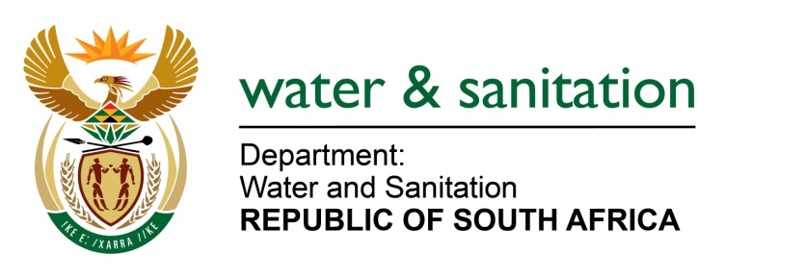

NATIONAL ASSEMBLY

FOR WRITTEN REPLY

QUESTION NO 1997

DATE OF PUBLICATION IN INTERNAL QUESTION PAPER: 30 JUNE 2017
(INTERNAL QUESTION PAPER NO. 24)
1997. Ms M S Khawula (EFF) to ask the Minister of Water and Sanitation:
(1) Does her department have documentation of all water infrastructures that existed before 1994; if not, what is the position in this regard; if so, what are the relevant details;
(2) did her department conduct water infrastructure audits since 1994; if not why not; if so;
(3) did the specified audit or survey include water infrastructure of the former Bantustans; if not, what is the position in this regard; if so, what are the relevant details? NW2212E
---00O00---
REPLY:
(1) Yes, the asset register of my Department contains that information of all infrastructures that existed before 1994.
(2) Yes, in 2007, my Department launched a project called “verification and valuation of all major water resource infrastructure” and produced an asset register. On an annual basis, verification is performed mainly to include assets that were not included in the 2007 verification exercise.
(3) Yes, the verification and valuation exercise of 2007 included all national water resource infrastructures including the former Bantustan water infrastructure.
---00O00---

