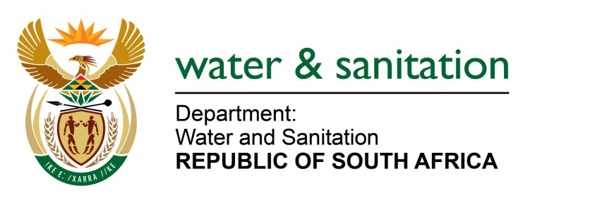

NATIONAL ASSEMBLY

FOR WRITTEN REPLY

QUESTION NO 1996

DATE OF PUBLICATION IN INTERNAL QUESTION PAPER: 20 MAY 2022
(INTERNAL QUESTION PAPER NO. 18)

1996. Mr L J Basson (DA) to ask the Minister of Water and Sanitation:

(1) Whether his department is involved in any way in the eight housing projects in the uMngeni Local Municipality that are being held up by the uMgungundlovu District Municipality due to their inability to provide bulk water and sanitation; if not, in what way will his department assist the uMgungundlovu District Municipality in the delivery of bulk services in order to complete the housing projects; if so, what are the full, relevant details of his department’s involvement.

(2) whether his department provided funding to the uMgungundlovu District Municipality for the provision of bulk water; if not, what is the position in this regard; if so, what amount was allocated?

NW2337E

---00O00---

MINISTER OF WATER AND SANITATION

- The Department of Water and Sanitation is not involved in the eight housing projects. If required, uMgungundlovu District Municipality may apply to the Department for RBIG funding. Alternatively, the district municipality may apply to CoGTA for MIG funding.

- As no application for RBIG funding has been received from uMgungundlovu Municipality, no funds are currently being provided to the municipality for construction of bulk water infrastructure to service the eight housing projects. The requirements for applying to the DWS for RBIG funding include a detailed feasibility study report, preliminary designs, an implementation readiness study report and a business plan from the municipality.

---00O00---

