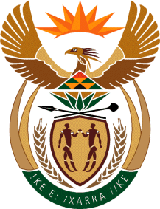
MINISTRY
SPORT AND RECREATION
REPUBLIC OF SOUTH AFRICA

Department of Sport and Recreation l Private Bag X896 l PRETORIA l 0001 l Regent Place l 66 Queen Street l Pretoria l 0001 l +27 (0)12 304 5158 l Fax: +27 (0)12 323 8426
Private Bag X9149 l Cape Town l 8000 l 2nd Floor Parliament Building l 120 Plain Street l CAPE TOWN l Tel: +27 21 469 5705 l Fax: +27 21 465 4402
www.srsa.gov.za
_____________________________________________________________________

NATIONAL ASSEMBLY

WRITTEN REPLY

QUESTION PAPER: No. 24 of 30 JUNE 2017

DATE OF REPLY: 24 JULY 2017

1995. Mr P G Moteka (EFF) asked the Minister of Sport and Recreation:
(a) What is the total number of sport facilities in the country that are accessible to the public free of charge, (b) what do the facilities consist of and (c) where are they located? NW2210E
______________________________________________________________________
The Minister of Sport and Recreation
REPLY:
(a) In 2016, the Department of Sport and Recreation South Africa conducted a national facilities count in all the 9 provinces of South Africa. Whilst the count revealed that there are 5 022 sport facilities around the country, it did not include a variable to determine if access to these facilities is free to the general public. This is part of the reason that the Department has deemed it appropriate to conduct a comprehensive national facility audit to look beyond the number and location of the facilities, but also to zoom into other aspects, including accessibility for the general public.

(b) Although a variable of free access to the public was not included in the facilities count, data about services offered in each of the facilities was generated.

(c) The facilities count also produced data on the geographic location of the facilities. The information is summarized in the National Facility Count Report, which may be availed to the Honourable Members of Parliament.

