environment fores & fisherie

t
s
bepertment
REnEvPlfounsmuecnto, FrDBreO5tU¥yzBHlvAdFFRlglhCeAftgg

NATIONAL ASSEMBLY

(For written taply)

QUESTION NO. 1994(NW2555E}

INTERNAL QUESTION PAPER NO.34 42020

DATE OF PUBLICATION: 28 Auguat 2020

Ma H S kinkier (DA) to ask the Minister of Forestry, Fisheries and the Environment:
Whether an export quota for lion bone is being con9ideed for 2020; knot, why not; Neo, what are the

1994. THE MINISTER OF FORESTRY, FI8IJERIE9 AND THE ENVIRONMENT REPLIES:

The judgement of National Council of the Society lot Prevention of Cmelfy to Animals v Minister of Enviion nental Affairs and Otheis on the lion bone export quota determination p«›cess requested the Minister to give consideration to welfare issues relating to lions in captivity when determining the quota. The Department was, therefore, not able b determine the 2019 lion bone export quota and such determination process Wa9 thu9 defa‹ted.

Regards
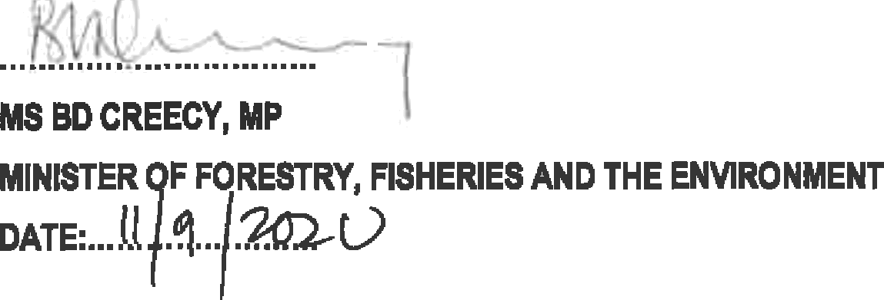

NATIONAL A3SEf/BLY QUESTION NO. 1904 Ng/2555E

