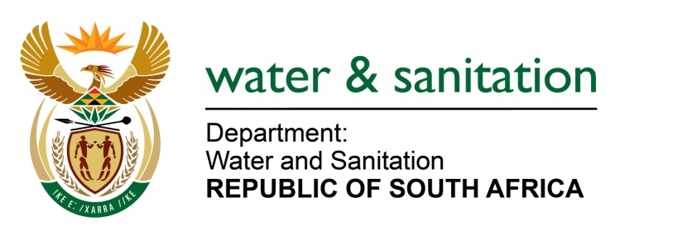

NATIONAL ASSEMBLY

FOR WRITTEN REPLY

QUESTION NO 1991

DATE OF PUBLICATION IN INTERNAL QUESTION PAPER:
(INTERNAL QUESTION PAPER NO. 19) 26 MAY 2023

1991. Mr Y Tetyana (EFF) to ask the Minister of Water and Sanitation:
What steps of intervention have been taken to curb the dysfunctionality which exists within the Amatola Water Board, where board members are able to influence operational matters by appointing senior managers who manipulate the awarding of tenders? NW2247E
---00O00---

MINISTER OF WATER AND SANITATION

The Department of Water and Sanitation is not aware of any dysfunctionality which exists within the Amatola Water Board.

Any allegations that are brought to the attention of the Minister, that involves the Water Boards, are investigated, and addressed accordingly.

---00O00---

