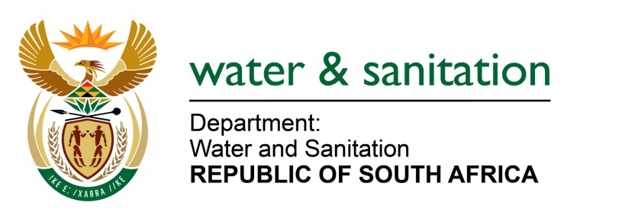

NATIONAL ASSEMBLY

FOR WRITTEN REPLY

QUESTION NO 1990

DATE OF PUBLICATION IN INTERNAL QUESTION PAPER:
(INTERNAL QUESTION PAPER NO. 19) 26 MAY 2023

1990. Mr Y Tetyana (EFF) to ask the Minister of Water and Sanitation:
What total number of board meetings have the Amatola Water Board had in the past 12 months, compared to what it is prescribed to have?
NW2246E

---00O00---

MINISTER OF WATER AND SANITATION
The Board of the Amatola Water had 12 meetings and 10 special board meetings, in the past 12 months. The prescribed number of meetings per year is six (6).

---00O00---

