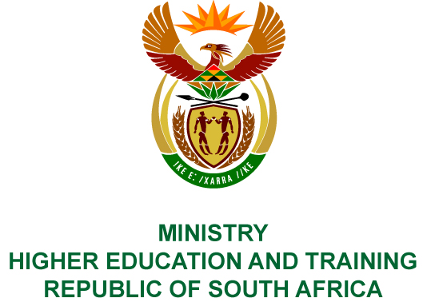
Private Bag X893, Pretoria, 0001, Tel (012) 312 5555, Fax (012) 323 5618
Private Bag X9192, Cape Town, 8000, Tel (021) 469 5150, Fax: (021) 465 7956
Memorandum from the Parliamentary Office
NATIONAL ASSEMBLY
FOR WRITTEN REPLY
QUESTION 199
DATE OF PUBLICATION OF INTERNAL QUESTION PAPER: 08/02/2018

(INTERNAL QUESTION PAPER NO 1 OF 2018)
Mrs H O Mkhaliphi (EFF) to ask the Minister of Higher Education and Training:
Did the National Institute for Humanities and Social Science use the services of a certain company (name furnished) on 14 July 2017, to travel from Kievits Kroon in Pretoria to 24 St Andrews Johannesburg; if not, what is the position in this regard; if so, (a) what (i) was the cost of each trip and (ii) are the details of those transported, (b) was the cheapest travel option taken, (c) did the spending comply with (i) National Treasury cost cutting measures and (ii) the regulations of (aa) her department and (bb) the Auditor-General of South Africa and (d) who approved the (i) trip and (ii) payment?
NW207E

REPLY:
The National Institute for Humanities and Social Sciences (NIHSS) has provided the following responses to the questions posed.
The services of Exclusive Treasure Tours was not used on 14 July 2017

COMPILER DETAILS
NAME AND SURNAME: MS PEARL WHITTLE
CONTACT: 012 312 5248
RECOMMENDATION
It is recommended that the Minister signs Parliamentary Question 199.

MR GF QONDE
DIRECTOR–GENERAL: HIGHER EDUCATION AND TRAINING
DATE:

PARLIAMENTARY QUESTION 199 IS APPROVED / NOT APPROVED / AMENDED.
COMMENT/S

PROF HB MKHIZE, MP
MINISTER OF HIGHER EDUCATION AND TRAINING
DATE:

