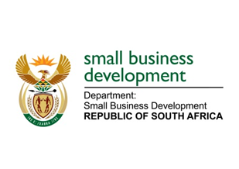
NATIONAL ASSEMBLY
QUESTION FOR WRITTEN REPLY
1985. Mr R W T Chance (DA) to ask the Minister of Small Business Development:

(1) What interaction has (a) she and/or (b) her department had with a certain company (Simodisa)

(2) what was the outcome of such interaction? NW2247E

REPLY:
(1) (a) The Minister has not formally met with the Simodisa Company. The Minister only met informally with the company on the margins of another engagement.
(b) The Department of Small Business Development has never had any interaction with the Simodisa Company.

