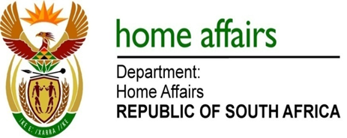

NATIONAL ASSEMBLY

QUESTION FOR WRITTEN REPLY

QUESTION NO. 1980

DATE OF PUBLICATION: Friday, 23 September 2016

INTERNAL QUESTION PAPER 29 OF 2016

1980. Mr J Vos (DA) to ask the Minister of Home Affairs:

By what date will the recommendations of the Inter-Ministerial Committee on Immigration regarding the amendment of the immigration regulations relating to (a) the requirement of unabridged certificates when travelling with minors and (b) visa exemptions for Brics countries be implemented? NW2291E
REPLY:

- The amendment to the Immigration Regulations has required the Department to undertake review of regulation 6 of the Regulations, with substitution in subregulation (12)(a) and (b). The establishment of the Immigration Advisory Board (IAB) is fundamental to this process. The IAB convened its first sitting on 3 June 2016 and was officially inaugurated on 20 July 2016. As its first order of business, the IAB reviewed the requirement for the issuance of the Strong Advisory and recommended that the proposed amendment and intent to publish a Strong Advisory be opened to public consultation through a published Gazette. The consultation period of 30 days commenced with the publication of Gazette No 40287 on 16 September 2016 and concluding on 14 October 2016. The IAB will convene a special sitting on 26 October 2016 to hear and consider comments made on the proposed amendment to the Immigration Regulations. It is expected that the amendments will be submitted for publication during November 2016.

(b) At its meeting on 20 August 2013, the BRICS Business Council requested BRICS governments to consider granting BRICS Business Executives long-term, multiple entry visas for the purpose of enhancing business activities. On 23 December 2014 the Minister granted approval for the issuance of visas for a period not exceeding 10 years, with each visit restricted to 30 days. A communication in this regard was transmitted to all South African Missions abroad with a request that visa applications be processed and finalised within five working days. In addition to this, it can be confirmed that all diplomatic and official or service passport holders of BRICS Member States are exempt from the requirement to apply for a visa before proceeding to the Republic of South Africa.

