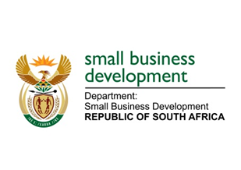
NATIONAL ASSEMBLY
QUESTION FOR WRITTEN REPLY
DUE TO PARLIAMENT: FRIDAY, 9 JUNE 2023

“1978. Mr K Ceza (EFF) to ask the Minister of Small Business Development:
What steps of intervention has she taken to prevent small businesses based in townships and owned by women and youth, from closing down as a result of power outages?” NW2230E

REPLY:
I am advised follows:
The Department of Small Business Development (DSBD) has put together a loadshedding relief package called the Power Purchase Product (PPP) to be implemented through its agency Small Enterprise Finance Agency (sefa). The PPP is financial package which aims to assist small and medium enterprises across South Africa who have been severely impacted by loadshedding. The programme will support these enterprises with a blended loan facility of up to R1 million. An amount of R 490 million is allocated inclusive of Seda support to product markets. The blended facility will be utilised for the acquisition of alternative energy sources as well as related working capital.

As part of our medium to long term strategy, a separate request was submitted to the National Treasury to allow non-Banking Financial Institutions such as the Khula Credit Guarantee to participate in the Bounce Back Scheme so that funding support to enterprises can be maximised.

