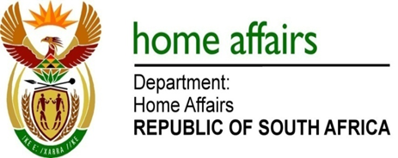

NATIONAL ASSEMBLY

QUESTION FOR WRITTEN REPLY

QUESTION NO. 1978

DATE OF PUBLICATION: Friday, 23 September 2016

INTERNAL QUESTION PAPER 29 OF 2016

1978. Mr M H Hoosen (DA) to ask the Minister of Home Affairs:

(a) For how many days has the online verification system been suspended on the website of his department, (b) what are the reasons for the suspension of the specified system and (c) by what date will the system be fully operational again? NW2289

REPLY:
- The online verification system has been suspended as of 11 March 2015 on the website of the Department.
- The system was accessed by almost everybody who has an idea of how an ID number is constituted, which led to ID number phishing, abuse of the system, denial of services to those who genuinely required using the system as it was intended for. The Department (DHA) also encountered some financial and insurance organisations verifying ID and status of their potential clients without client consent and bypassing of departmental processes when it comes to identity of citizens. All these led to violation of the current legislation and clogging of DHA website.
- At the moment there is no envisaged date to open up the system, but there are processes in place to ensure that those who need this service can have access to it. Entities that require online verification of their clients ID and status must follow the prescribed process for application of secure access to the service and are to be governed through a Memorandum of Understanding (MOU) to protect citizens information.

