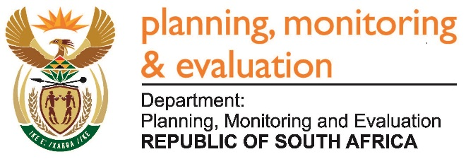 |  | 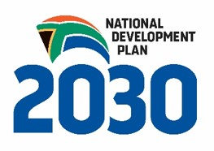
Private Bag X944, PRETORIA, 0001. Union Buildings East Wing, Government Avenue, PRETORIA
Tel: 012 312 0307. www.dpme.gov.za
_____________________
NATIONAL ASSEMBLY
QUESTIONS FOR WRITTEN REPLY

1973. Mr A P van der Westhuizen (DA) to ask the Minister in The Presidency:

(a) What number of legal municipal invoices did each (i) national and (ii) provincial department not pay within the prescribed 30 days of receipt of the specified invoices as at (aa) 30 June 2014, (bb) 30 June 2015 and (cc) 30 June 2016 and (b) which municipalities were affected in each case? NW2284E

Reply:

The DPME does not have data in relation to the number of legal invoices owed to municipalities by national and provincial departments. The Department of Public Works is currently undertaking a project on debt owed by national and provincial departments.

