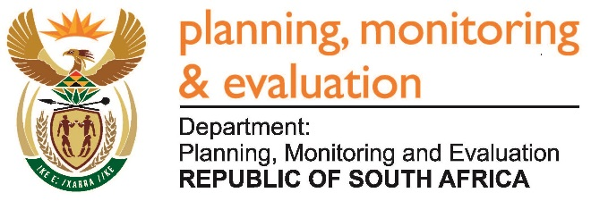 |  | 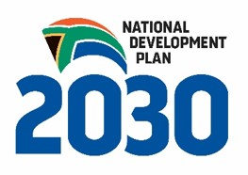
Private Bag X944, PRETORIA, 0001. Union Buildings East Wing, Government Avenue, PRETORIA
Tel: 012 312 0307. www.dpme.gov.za
_____________________
NATIONAL ASSEMBLY
QUESTIONS FOR WRITTEN REPLY

1972. Mr A P van der Westhuizen (DA) to ask the Minister in The Presidency:

What number of legal invoices did each (a) national and (b) provincial department not pay within the prescribed 30 days of receipt of the specified invoices as at (i) 30 June 2014, (ii) 30 June 2015 and (iii) 30 June 2016? NW2283E

Reply:

The tables below show the number of valid invoices not paid within the prescribed 30 days by both the national and provincial departments. The information is presented in terms of (i) invoices paid after 30 days (i.e. although paid, it was not paid within the prescribed 30 days period) and (ii) invoices older than 30 days not yet paid as at the indicated dates.

Table 1: National Departments:
Invoices paid after 30 days |  | Invoices older than 30 days not paid
June 2014 | 116 | June 2014 | 58
June 2015 | 13803 | June 2015 | 4544
June 2016 | 17668 | June 2016 | 12870

Table 2: Provincial Departments

Invoices paid after 30 days |  | Invoices older than 30 days not paid
June 2014 | 0 | June 2014 | 0
June 2015 | 30466 | June 2015 | 32339
June 2016 | 29306 | June 2016 | 39833

