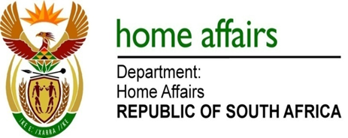

NATIONAL ASSEMBLY

QUESTION FOR WRITTEN REPLY

QUESTION NO. 1971

DATE OF PUBLICATION: FRIDAY, 8 JUNE 2018

INTERNAL QUESTION PAPER 20 OF 2018

1971. Mr M H Hoosen (DA) to ask the Minister of Home Affairs:

What (a) are the minimum educational and experience requirements for (i) Refugee Status Determination officers, (ii) Refugee Appeal Board members and (iii) Standing Committee for Refugee Affairs members and (b)(i) training and (ii) support materials does his department provide for the specified members? NW2130E

REPLY:

Section 10 (4) and 13 (2) of Refugee Act 130 of 1998 states that one member of SCRA as well as RAB must be legally qualified to serve on the board. The Department of Home Affairs (DHA) however requires that a member of SCRA as well as RAB should have LLB/Legal degree or equivalent qualification with three years of experience in Legal or Immigration Field relevant to Asylum Seeker Management Environment.

Section 8 (3) of Refugee Act 130 of 1198 requires that the DG should ensure that Refugee Reception Officers (RRO) and Refugee Status Determination Officers (RSDO) appointed under this section receives the additional training necessary to enable them to perform their functions properly.

The Learning Academy annually plans and provides Asylum Seeker Management related training to RROs and RSDOs. This training is offered mainly through NQF 5 qualification (National Certificate: Home Affairs Services) registered with the South African Qualifications Authority (SAQA). Some of the Unit Standards offered within this qualification are Adjudicate a claim for Refugee Status, Refugee Affairs, Human Rights and Counter Xenophobia. The Learning Academy further provides additional relevant training outside the National Certificate: Home Affairs such as systems training (NIIS), Case Management System, Performance Management, Diversity (LGBTI), Automated Booking Terminal System and DHA 1590 Application Forms (New Application Forms).

The Learning Academy has planned four training and development interventions (Refugee Law, Country of Origin Research, Counter Xenophobia and Social Cohesion and Foreign Languages) during the financial year 2018/2019 to capacitate RROs and RSDOs. The Learning Academy consults regularly with SCRA on training related matters as depicted in section 8 (3) and 39 of the Refugees Act, 1998.

The Learning Academy has provided training to SCRA and RAB administrative staff in the past. SCRA and RAB board members fall outside the scope of the DHA as they are appointed according to Refugee Act 130 of 1998 and not the Public Service Act. They are also expected to function without any bias and maintain their independence at all times as specified in section 9 (2) and 12 (3) of the Refugees Act, 1998.

