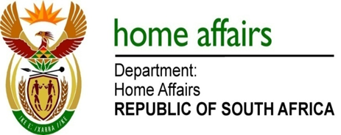

NATIONAL ASSEMBLY

QUESTION FOR WRITTEN REPLY

QUESTION NO. 1970

DATE OF PUBLICATION: FRIDAY, 8 JUNE 2018

INTERNAL QUESTION PAPER 20 OF 2018

1970. Mr M H Hoosen (DA) to ask the Minister of Home Affairs:

(1) What number of rejected asylum applications were (a) taken on review, (b) opposed by his department and (c) successful at court (i) in each of the past five calendar years and (ii) since 1 January 2018;
(2) were any directives given to or policies adopted by (a) the State Attorney or (b) refugee reception offices to oppose or reject (i) every application for the review of asylum, (ii) all applications or (iii) applications from specific countries? NW2129E

REPLY:

(1)(a) As per the table below:

Year | Judicial Reviews
2013 | 746
2014 | 522
2015 | 1282
2016 | 887
2017 | 1128
2018 | 723
Total | 5288

(1)(b) All these judicial review applications were opposed.

(1)(c) The Department does not have a litigation case management system in terms of which matters that were won or lost in court are recorded. The only system that is currently in use is a basic system that merely records new court matters.

- There are no directives given to or policies adopted by the State Attorney and/or Refugee Reception Offices to oppose or reject every application for the review of asylum, all applications or applications from specific countries.

