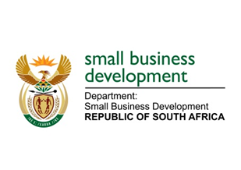
NATIONAL ASSEMBLY
QUESTION FOR WRITTEN REPLY
DUE TO PARLIAMENT: 25 FEBRUARY 2022

197. Mr M S Mabika (DA) to ask the Minister of Small Business Development:
(a) What number of supplier invoices currently remain unpaid by (i) her department and (ii) each entity reporting to her for more than (aa) 30 days, (bb) 60 days, (cc) 90 days and (dd) 120 days, (b) what is the in each case and (c) by what date is it envisaged that the outstanding amounts will be settled? NW201E

REPLY: I have been advised by the department as follows:

(a)(i) Department of Small Business Development (DSBD)
(aa) | Number of supplier invoices unpaid by 30 days | None.
(bb) | Number of supplier invoices unpaid by 60 days | None.
(cc) | Number of supplier invoices unpaid by 90 days | None.
(dd) | Number of supplier invoices unpaid by 120 days | None.
(b) | Total amount outstanding | R0.00
(c) | Date envisaged to settle outstanding amounts | N/A
(b)(ii) Small Enterprise Development Agency (Seda)
(aa) | Number of supplier invoices unpaid by 30 days | None.
(bb) | Number of supplier invoices unpaid by 60 days | None.
(cc) | Number of supplier invoices unpaid by 90 days | None.
(dd) | Number of supplier invoices unpaid by 120 days | None.
(b) | Total amount outstanding | R0.00
(c) | Date envisaged to settle outstanding amounts | N/A
(b)(ii) Small Enterprise Finance Agency (sefa)
(aa) | Number of supplier invoices unpaid by 30 days | 1 (One).
(bb) | Number of supplier invoices unpaid by 60 days | None.
(cc) | Number of supplier invoices unpaid by 90 days | None.
(dd) | Number of supplier invoices unpaid by 120 days | None.
(b) | Total amount outstanding | R 69 455.40
(c) | Date envisaged to settle outstanding amounts | Payment is expected to be made to the client by the 28 February 2022.

MS STELLA TEMBISA NDABENI-ABRAHAMS, MP
MINISTER FOR SMALL BUSINESS DEVELOPMENT

