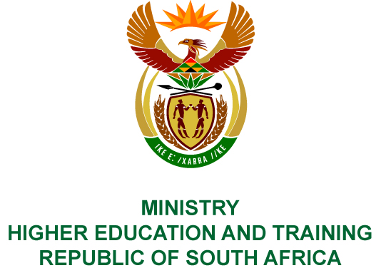
Private Bag X893, Pretoria, 0001, Tel (012) 312 5555, Fax (012) 323 5618
Private Bag X9192, Cape Town, 8000, Tel (021) 469 5150, Fax: (021) 465 7956
Memorandum from the Parliamentary Office
NATIONAL ASSEMBLY
FOR WRITTEN REPLY
QUESTION 1961
DATE OF PUBLICATION OF INTERNAL QUESTION PAPER: 08/06/2018
(INTERNAL QUESTION PAPER NO 20 OF 2018)
Prof B Bozzoli (DA) to ask the Minister of Higher Education and Training:
(a) What is the status of her department’s court application to take the Public Protector’s report on maladministration at the Tshwane South Technical and Vocational Education and Training College on review and (b) on what date is the case expected to be finalised?
NW2120E
REPLY:
- The Department has filed its supplementary affidavit, and the Office of the Public Protector is yet to file its answering affidavit. The attorneys for the Public Protector intend filing a condonation application for the late filing of its answering affidavit, where after the Office of the State Attorney will set the matter down for hearing.
- As the Clerk of the Court determines the court dates, the Department is unable to indicate when the case will be finalised.

