FOR WRITTEN REPLY QUESTION 196

NATIONAL ASSEMBLY
36/1/4/1(201900021)

DATE OF PUBLICATION IN INTERNAL QUESTION PAPER: 15 FEBRUARY 2019 fINTERNAL QUESTION PAPER NO 2-2019)

196. Ms D Kohler (DA) to ask the Minister of Police:

(a) What number of senior management level employees, including heads of departments, in (i) his department and (ii) each entity reporting to him have criminal records and (b) in each case, (i) what is the (aa) full name and (bb) position of the specified employee and (ii) what are the relevant details of the crimes for which each employee was convicted?

REPLY:

The South African below.

(a)(i)

(a)(ii)

(b)(i)(aa) and (bb)

(b)(ii)
NW206E

Police Service (SAPS) has verified the information, as provided

To date, a total of 32 members of the Senior Management Service (SMS) in the SAPS, have criminal records against their names. The Head of the SAPS does not have a criminal conviction against his name.

The SAPS is not in a position to provide this information.

The SAPS is not in a position to provide the information, since it contains personal information, relating to the members concerned and the disclosure will constitute an unreasonable violation of the priVacy of the members concerned.

The convictions relate to the following matters:
Three members have offences related to the contravention of the “Arms and Ammunition Act and the Firearms Control Act".
A total of 19 members have offences related to the contravention of road traffic legislation.

2

One member has an offence related to the contravention of liquor legislation, over and above the traffic offence.
Three members have offences related to the contravention of internal security legislation.
Seven members have common law related offences, namely; fraud, publiC Violence, contempt of court, malicious damage to property and assault respectively.

Reply to question 196 recommended/

GENERAL AFRICAN POLICE SERVICE
OM E (SOE
UI

Date:

Reply to question 196 approved/

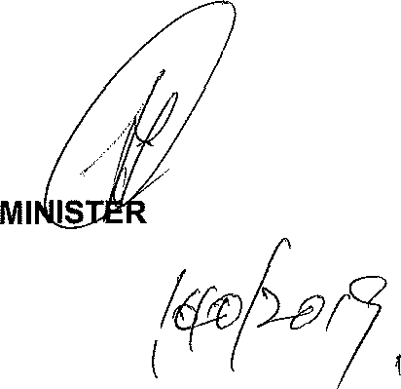

OF POLICE BH CELE, MP
Date:

