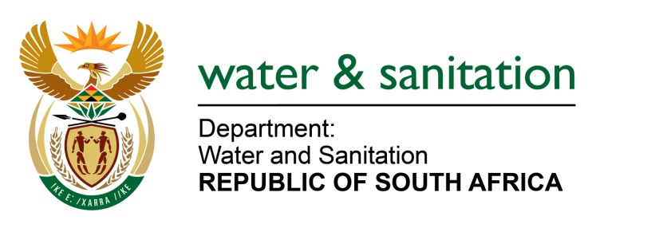

NATIONAL ASSEMBLY

FOR WRITTEN REPLY

QUESTION NO 1958

DATE OF PUBLICATION IN INTERNAL QUESTION PAPER: 26 MAY 2023
(INTERNAL QUESTION PAPER NO. 19)
1958. Mrs M R Mohlala (EFF) to ask the Minister of Water and Sanitation:
What immediate action has he taken to address the ongoing water crisis in Makhanda, specifically the massive water leak that has been affecting the Moeggesukkel community for over a year and the malfunctioning standpipe taps in the area? NW2191E
---00O00---
MINISTER OF WATER AND SANITATION
The Department, collaborating with the Amatola Water Board, mobilised the operations team from Amatola Water to join the Makhanda team to investigate the reason for the non-functionality of the Waainek Water Treatment Plant. Investigations pointed to the inability of pumps to abstract water from the Howisons Poort Dam to Waainek Water Treatment Works in the western side of Makhanda. Specialist Divers were called in to investigate any blockages on valves on the dam wall and removed some debris that was found. The pump was taken off-site for further testing and found to be functional. Current investigations on the pipeline are ongoing and divers with specialist equipment are again hard at work to investigate and resolve the current water challenges. Furthermore, the following is being done to assist the municipality:

- The Department, in consultation with provincial government is mobilising further resources to enable Amatola Water to start with critical emergency work within Makhanda. Amatola Water has already costed the works and its proposal has been submitted to Cogta and Office of the Premier for funding.

- As part of its ongoing regulatory activities, the Department also engaged the Makhanda Municipality regarding non-compliance on loading drinking water monitoring data on the Integrated Regulatory Information System (IRIS)

- The levels of E.coli levels have since been brought under control and the water supply is being closely monitored. In addition, the boil water notice was issued by the municipality.

- Ongoing construction of the James Kleynhans (Phase 2), funded under the Regional Bulk Infrastructure Grant (RBIG) to the upgrade the Water Treatment Works from a 10Mℓ/day to a 20Mℓ/day plant which supplies the town. Construction started on 18 January 2023 and the practical completion is planned for 15 December 2023. An additional 10Mℓ/day project to upgrade the existing system will commence by end of June 2023.
- It should be noted that the Moeggesukkel community mentioned in the question could not be located nor is it known by the Makhanda Municipality, however reported leaks in the municipality are being addressed as an ongoing activity.
---00O00---

