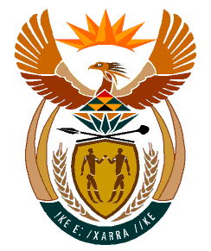

MINISTRY
HUMAN SETTLEMENTS
REPUBLIC OF SOUTH AFRICA

Private Bag X645, Pretoria, 0001. Tel: (012) 421 1309, Fax: (012) 341 8513

Private Bag X9029, Cape Town, 8000. Tel (021) 466 7603, Fax: (021) 466 3610

NATIONAL ASSEMBLY
QUESTION FOR WRITTEN REPLY
QUESTION NUMBER: PQ 1958 (NW2298E)

DATE OF PUBLICATION: 20 MAY 2022

Ms E L Powell (DA) to ask the Minister of Human Settlements:

Whether, given that 11 years have now passed since the Sectional Titles Schemes Management Act, Act No. 8 of 2011, was gazetted in terms of which the Sectional Titles Schemes Management Advisory Council was formally established, she will furnish Ms E L Powell with the timelines for the actual, real-world establishment of the Council as provided for in section 18 of the Act.

REPLY:
The appointment of the Sectional Title Schemes Management Advisory Council is in progress and should be finalised by 15 July 2022.

