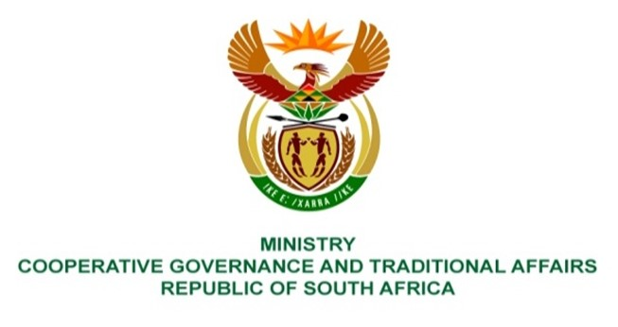

NATIONAL ASSEMBLY
QUESTIONS FOR WRITTEN REPLY

QUESTION NUMBER 1958
DATE OF PUBLICATION: 27 August 2021

QUESTION:

1958: Mrs S M Mokgotho (EFF) to ask the Minister of Cooperative Governance and Traditional Affairs:

What steps has she and/or her department taken to resolve the problem of sewer spillage onto the streets in Ward 2 of the Naledi Local Municipality?

REPLY:
Dr Ruth Segomotsi Mompati Disrict Municipality (DRSDM) is the Water Services Authority (WSA) in its area of jurisdiction which includes Naledi Local Municipality (NLM) area. The Water Services Act, 108 of 1997 defines a WSA as any municipality responsible for ensuring access to both water and sanitation services. The sanitation services include the management of sewered systems. In executing its functions, which include the WSA function, DRSDM gets grant funding and technical support from the provincial and national government departments. NLM monitors the projects implemented by the district in its area of jurisdiction and liases with DRSDM. The Department of Corporative Governance (DCOG), through the Municipal Infrastructure Support Agent (MISA) provides technical support to both DRSMD and NLM in accordance with the District Development Model (DDM).
According to NLM the sewer spillages in Ward 2 in NLM are caused by the blocked sewer line and faulty manhole in Sonneblom Street, Colridge (in Vryburg). DRSDM appointed a contractor to perform the necessary construction repairs under emergency works. NLM is monitoring the works and liasing with DRSDM.

The contractor has already installed a temporary pump and bypass line (102m long) to avert the spillage problem and to re-route the live sewerage for construction repair works to be performed under workable dry conditions. According to NLM the bypass system has been in operation since 10 September 2021 and the work area has dried out sufficiently, as shown on the picture below, to allow repair works to be conducted.

The excavation for the pipeline replacement and new manhole construction is underway. Completion and re-commissioning of the effected sewerage infrastructure is anticipated to be by the end of October 2021 subject to favourable weather conditions as it is now in the rainy season.

Supporting Photographs:
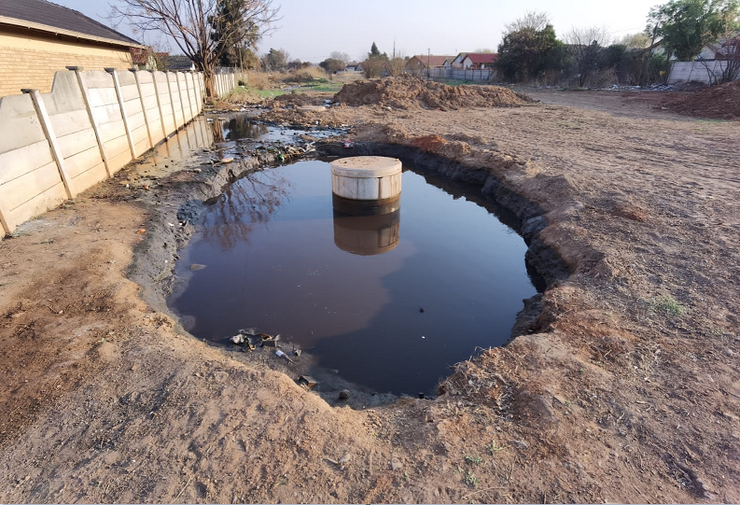
Photo 1: Faulty sewer line before commencement of repair works
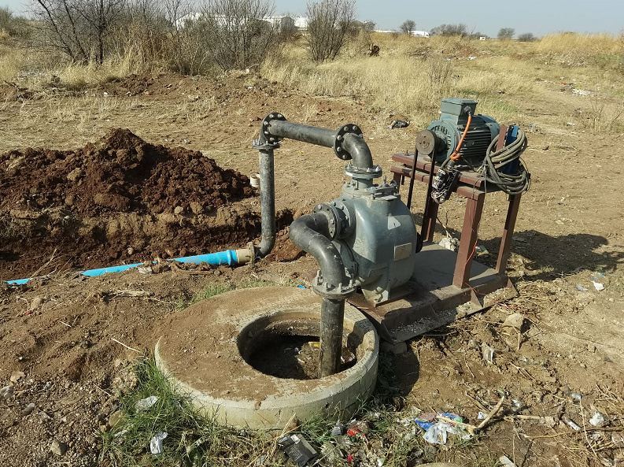
Photo 2: Temporary pump and bypass line installed
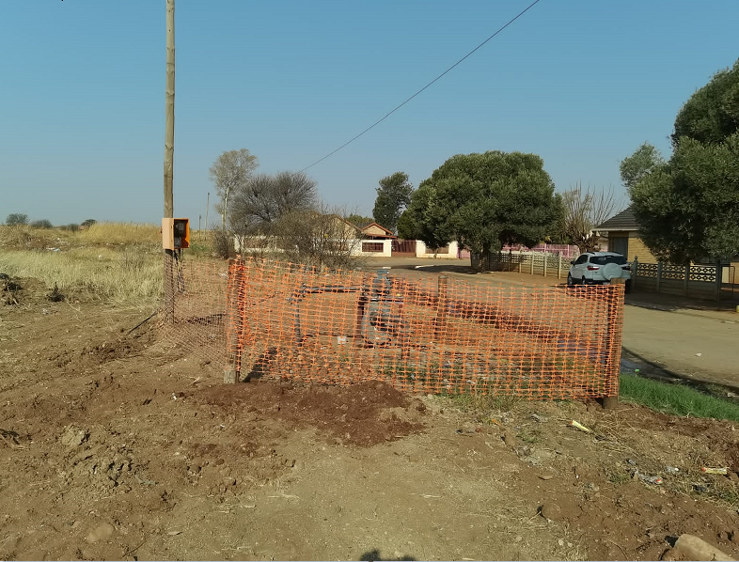
Photo 3: Temporary pump secured with barricade netting

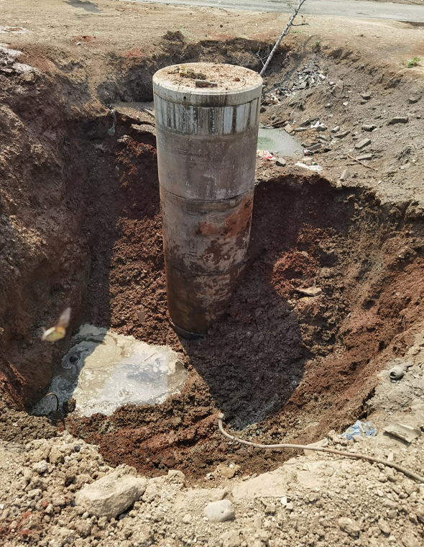
Photo 4: Excavations around manhole (note area dried out)

