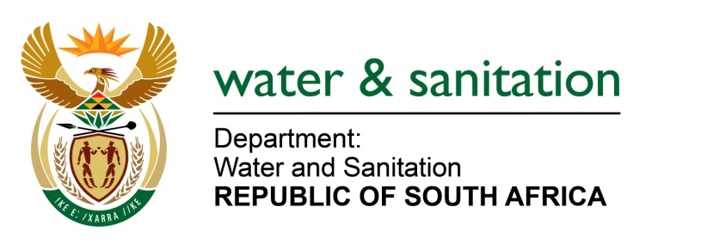

NATIONAL ASSEMBLY

FOR WRITTEN REPLY

QUESTION NO 1957

DATE OF PUBLICATION IN INTERNAL QUESTION PAPER: 26 MAY 2023
(INTERNAL QUESTION PAPER NO. 19)

1957. Mrs M R Mohlala (EFF) to ask the Minister of Water and Sanitation:
What steps has he taken to address the water supply crisis in Gauteng, where Rand Water is unable to meet the province’s consumers’ demands, with a variance of 9% between the current water demand and supply and a significant amount of supply being lost within municipal systems due to non-revenue water and physical losses such as leaks and burst pipes?
NW2190E
---00O00---
MINISTER OF WATER AND SANITATION

The Department of Water and Sanitation has held numerous engagements with Rand Water and the municipalities within Gauteng, wherein municipalities were requested to present their plans to mitigate against the water supply challenges in the province and to implement turn-around strategies.

The DWS has advised Rand Water and municipalities to develop projections of future demand and implement infrastructure development programmes to cater for growing demand. The following will be prioritised by all municipalities in Gauteng to mitigate water supply challenges:
- Reduction of water losses by addressing illegal connections in formal settlement areas where water theft is occurring
- Regularisation of authorized unbilled consumptions in areas such as informal settlements
- Reduction and control of unplanned human settlements in various municipal areas.
- Implementation of Water Conservation and Demand Management (WCDM) measures to reduce demand.
- Construction of additional spare storage capacity through construction of additional reservoirs.
The DWS has undertaken the implementation and acceleration of the Lesotho Highlands Water Project II to augment water supply to the Gauteng Province through the Integrated Vaal River System (IVRS). The target date for completion of this project and associated infrastructure is December 2027

---00O00---

