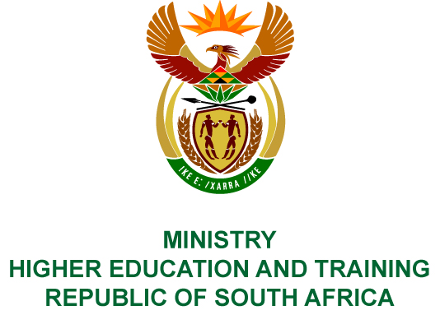
Private Bag X893, Pretoria, 0001, Tel (012) 312 5555, Fax (012) 323 5618
Private Bag X9192, Cape Town, 8000, Tel (021) 469 5150, Fax: (021) 465 7956
Memorandum from the Parliamentary Office
NATIONAL ASSEMBLY
FOR WRITTEN REPLY
QUESTION 195
DATE OF PUBLICATION OF INTERNAL QUESTION PAPER: 08/02/2018

(INTERNAL QUESTION PAPER NO 1 OF 2018)
Mr N Paulsen (EFF) to ask the Minister of Higher Education and Training:
Did the National Institute for the Humanities and Social Sciences use the services of a certain company (name furnished) on 7 July 2017 to travel from a certain address (details furnished) to O R Tambo International Airport and return; if not, what is the position in this regard; if so, (a) what (i) was the cost of each trip and (ii) are the details of the persons who were transported, (b) was the service provided by the specified company the most cost effective travel option taken, (c) did the spending comply with (i) National Treasury cost cutting measures and (ii) the regulations of (aa) his department and (bb) the Auditor-General of South Africa and (d) who approved the trip and payment thereof?
NW203E
REPLY:
The National Institute for Humanities and Social Sciences (NIHSS) has provided the following responses to the questions posed.
The NIHSS did not use the services of Exclusive Treasure Tours on 7 July 2017.

COMPILER DETAILS
NAME AND SURNAME: MS PEARL WHITTLE
CONTACT: 012 312 5248
RECOMMENDATION
It is recommended that the Minister signs Parliamentary Question 195.

MR GF QONDE
DIRECTOR–GENERAL: HIGHER EDUCATION AND TRAINING
DATE:

PARLIAMENTARY QUESTION 195 IS APPROVED / NOT APPROVED / AMENDED.
COMMENT/S

PROF HB MKHIZE, MP
MINISTER OF HIGHER EDUCATION AND TRAINING
DATE:

