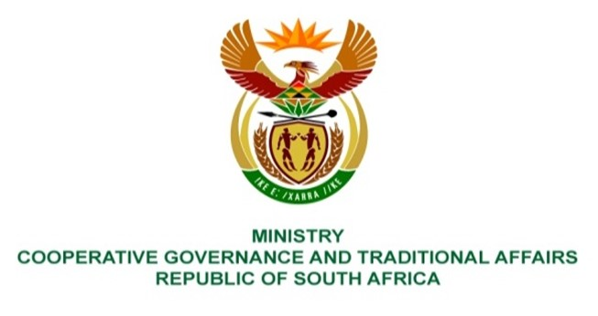

NATIONAL ASSEMBLY
QUESTIONS FOR WRITTEN REPLY

QUESTION NUMBER 2021/1948
DATE OF PUBLICATION: 27 AUGUST 2021

Mrs C C S Motsepe (EFF) to ask the Minister of Cooperative Governance and Traditional Affairs:
QUESTION:

By what date will a forensic investigation be conducted by her department into what happened to the missing R49 million from the coffers of the Dr Ruth Segomotsi Mompati District Municipality in the North West, which had invested taxpayers’ money to the amount of R150 million with VBS Mutual Bank?

REPLY:

The response below was provided by the province:

Various investigations have been instituted by the province, municipality and law enforcement agencies in relation to the Venda Building Society Mutual Bank (the VBS) investments. On 28 March 2019, the municipality Council took resolution number 44/2018/19 to appoint an independent investigator to investigate allegations relating to the missing R49 million. The investigation report has been completed and there is no record of the missing R49 million and the Curator also confirmed that the amount that is in the records of VBS is R150 million. As such, there is no need for the department to institute further investigation on this matter.

Some of the investigations which have been conducted with regard to the above mentioned allegations are listed below:

Report | Description
10/10/2018 | Report by Sekela Xabiso to HoD of Department of Finance tittled:  “INVESTIGATION INTO THE INVESTMENTS MADE BY NORTH WEST MUNICIPALITIES AT VBS MUTUAL BANK (DR RS MOMPATI DISTRICT MUNICIPALITY)”
23/02/2021 | Report by Dr Ruth Segomotsi Mompati District Municipality to MEC Ms Cwale tittled:  “REQUEST FOR PROGRESS REPORT ON THE IMPLEMENTATIONS OF RECOMMENDATIONS EMANATING FROM FORENSIC REPORT IN RESPECT OF THE VENDA BUILDING SOCIETY MUTUAL BANK (VBS) INVESTIGATION”
24/02/2021 | Report by Katake Attorneys to Dr RS Mompati District Municipality titled:  “LEGAL OPINION REGARDING LEGALITY OF DISCIPLINARY PROCESS AGAINST THE MUNICIPAL MANAGER”

