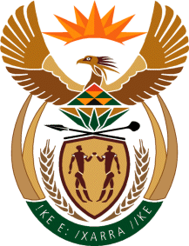

THE PRESIDENCY

REPUBLIC OF SOUTH AFRICA
Private Bag X1000, Pretoria, 0001

NATIONAL ASSEMBLY

QUESTIONS FOR WRITTEN REPLY
DATE OF PUBLICATION: 26 MAY 2023
QUESTION NUMBER: 1947 (NW2030E)

1947. Ms P Madokwe (EFF) to ask the Minister in The Presidency for Electricity:
What is (a) his official position regarding recent reports that load shedding hours almost quintupled between 2021 and 2022, and that in 2023 less than five days were without loadshedding and (b) being done to hold those who failed to resolve the loadshedding debacle accountable, but instead put the Republic in a worse off position than before?
REPLY
The Eskom board and management continues to deal with management and operational shortcomings that impede the optimisation of generation capacity, in this regard, the necessary disciplinary action is being pursued as required by relevant legislation and sector collective agreements.
In addition, an Energy Safety and Security Priority Committee was established to address ESKOM-related crime on an inter-departmental, multi-disciplinary basis to address the objectives of Work Stream Six of the National Energy Crisis Committee (NECOM).

A total of 1952 Eskom-related cases were reported to the SA Police Service between 1 April 2022 and 29 May 2023, with 1405 cases still under investigation, and 126 arrests have been made.
Whilst much remains, these interventions are beginning to turn the situation around, and there are indications that operational measures implemented have clearly disrupted the activities of criminal syndicates

