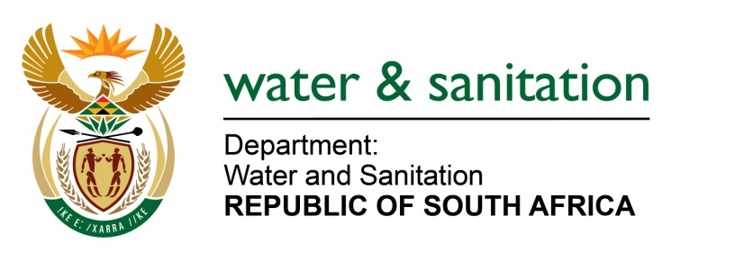

NATIONAL ASSEMBLY

FOR WRITTEN REPLY

QUESTION NO 1947

DATE OF PUBLICATION IN INTERNAL QUESTION PAPER: 20 MAY 2022
(INTERNAL QUESTION PAPER NO. 18)

1947. Ms A M M Weber (DA) to ask the Minister of Water and Sanitation:

(1) Whether, with regard to the acid mine drainage spill into the Wilge and Olifants Rivers in Mpumalanga in February 2022 from the Kromdraai Gold Mine belonging to a certain company (name furnished), his department gave a verbal directive to the specified mine before the spillage happened; if not, why not; if so, (a) on what date was the directive given and (b) what was the directive.

(2) whether his department gave a written directive to the specified company regarding the leak at the shaft at Kromdraai Gold Mine; if not, why not; if so, on what date.

(3) whether he will furnish Ms A M M Weber with a copy of the directive; if not, why not; if so, on what date;

(4) whether his department referred the matter into the acid mine drainage spill at Kromdraai Gold Mine for criminal investigation; if not, why not; if so, what are the relevant details?

NW2287E
---00O00---

MINISTER OF WATER AND SANITATION

(1)(a) The Department issued a verbal directive to Kromdraai Colliery during the site investigation on 17 February 2022 and issued a written directive confirming the verbal directive on 21 February 2022.

(1)(b) The directive issued instructed Kromdraai Mine to do the following:
- Take all reasonable measures to contain and minimise the effects of the incident.
- Undertake clean-up procedures.
- Remedy the effects of the incident.
- Appoint a suitably qualified environmental consultant to compile a rehabilitation plan for all the affected areas within ten (10) days upon receipt of this directive, which must be submitted to the Department for recommendations. The rehabilitation plan must entail amongst the others, the nature and extent of the impacts that the incident posed or may pose on the water resource and measures that will be implemented to remediate or mitigate the impacts with clear timeframes and descriptions of how and when each remedial/mitigation action will be implemented.
- Implement all the recommendations contained in the rehabilitation plan and rehabilitate the areas affected by the water use activities within thirty (30) days of Departmental approval of the rehabilitation plan.

(2) The department issued a directive in terms of Section 20(4)(d) of the National Water Act,1998 (Act No 36 of 1998) to Kromdraai Colliery, dated 21 February 2022.

(3) A copy of the directive is attached as Annexure A.

(4) A criminal case was opened with Vosman Police Station in eMalahleni, case number 299/03/2022. Both internal and external witnesses have made their statements in connection with the pollution incident.
---00O00---

