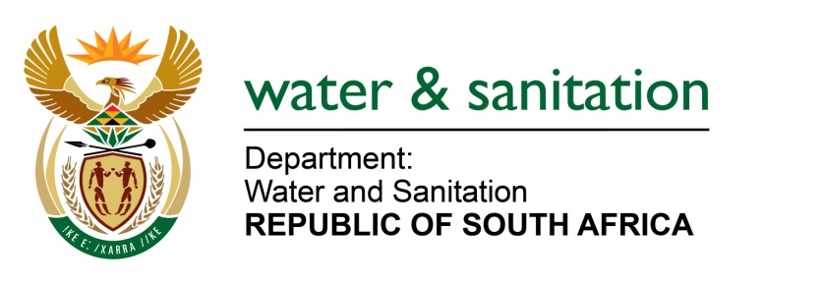

NATIONAL ASSEMBLY

FOR WRITTEN REPLY

QUESTION NO 1946

DATE OF PUBLICATION IN INTERNAL QUESTION PAPER: 23 JUNE 2017
(INTERNAL QUESTION PAPER NO. 23)
1946. Mr L J Basson (DA) to ask the Minister of Water and Sanitation:

With regard to the upgrade of Rand Water System 5, (a) how many tenders that were approved exceeded best of tender, (b) what is the amount that was exceeded in each case and (c) what are the names of the companies in each case? NW2158E
---00O00---
REPLY:

Requesting the Honorable Member to refer to the response provided in NA 1945 of 23 June 2017.

---00O00---

