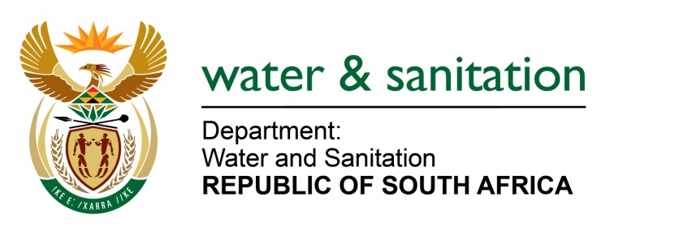

NATIONAL ASSEMBLY

FOR WRITTEN REPLY

QUESTION NO 1945

DATE OF PUBLICATION IN INTERNAL QUESTION PAPER: 23 JUNE 2017
(INTERNAL QUESTION PAPER NO. 23)
1945. Mr L J Basson (DA) to ask the Minister of Water and Sanitation:
(1) With regard to the upgrade of Rand Water System 5, (a) how many contracts were issued, (b) what are the names of companies that were awarded the contracts, (c) how many companies are on time with their projects and (d) how many of the companies have exceeded their budgets;
(2) how many of the specified companies are BEE compliant;
(3) whether each of the specified companies are Construction Industry Development Board (CIDB) certified; if not, why not;
(4) will she furnish Mr L J Basson with copies of the CIDB certification on all the contracts; if not, why not; if so, by when? NW2157E
---00O00---
REPLY:
(1) There are 11 contracts issued and 10 appointed to date. Refer to Annexure A for the details.

(2) Yes, all the companies are BEE compliant and it was a requirement for all the tenders.

(3) Yes, all the service providers are CIDB certified.

(4) Refer to Annexure B for the copies of the CIDB certificates of all contracts.
---00O00---

