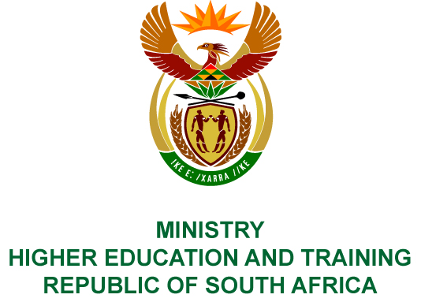
Private Bag X893, Pretoria, 0001, Tel (012) 312 5555, Fax (012) 323 5618
Private Bag X9192, Cape Town, 8000, Tel (021) 469 5150, Fax: (021) 465 7956
Memorandum from the Parliamentary Office
NATIONAL ASSEMBLY
FOR WRITTEN REPLY
QUESTION 194
DATE OF PUBLICATION OF INTERNAL QUESTION PAPER: 08/02/2018

(INTERNAL QUESTION PAPER NO 1 OF 2018)
Mrs H O Mkhaliphi (EFF) to ask the Minister of Higher Education and Training:
Did the Chairperson of the National Institute for the Humanities and Social Sciences travel from Johannesburg to Hong Kong on 8 June 2017 and return on 11 June 2017; if not, what is the position in this regard; if so, (a) what was the (i) purpose of the specified visit and (ii) price of the ticket, (b) what was the (i) name and (ii) fee of the travel agency that was used, (c) were the services provided by the specified travel agency the most cost effective travel option taken, (d) did the spending comply with (i) National Treasury cost cutting measures and (ii) the regulations of (aa) her department and (bb) the Auditor-General of South Africa and (e) who approved the trip and payment thereof?
NW202E
REPLY:
The National Institute for Humanities and Social Sciences (NIHSS) has provided the following responses to the questions posed.
The Chairperson, Professor Ari Sitas, flew from Johannesburg to Fuzhou, China via Hong Kong on 8 June 2017 and returned on 11 June 2017.
- (i) The purpose of the visit was to attend the 5th BRICS Think Tanks Council meeting and 9th BRICS Academic Forum in Fuzhou.
(ii) The price of the ticket was R102 910 (excluding airport taxes).
- (i) The travel agency used was Travel With Flair.
(ii) The fee was R440.
- It was the cheapest travel option.
- (i) The expenditure complied with the NIHSS’s policies. The NIHSS is neither a Department, nor a constitutional institution, nor a public entity listed in Schedule 2 or 3, and therefore the Public Finance Management Act is not applicable to the NIHSS.
(ii) (aa) Spending is managed by the NIHSS in terms of its policies.
(bb) The Auditor-General of South Africa audits the NIHSS in terms of Section 38 of the Higher Education Act and since its inception has received unqualified audit opinions.
- The Chief Executive Officer, Professor Sarah Mosoetsa, approved the trip and expenditure.

COMPILER DETAILS
NAME AND SURNAME: MS PEARL WHITTLE
CONTACT: 012 312 5248
RECOMMENDATION
It is recommended that the Minister signs Parliamentary Question 194.

MR GF QONDE
DIRECTOR–GENERAL: HIGHER EDUCATION AND TRAINING
DATE:

PARLIAMENTARY QUESTION 194 IS APPROVED / NOT APPROVED / AMENDED.
COMMENT/S

PROF HB MKHIZE, MP
MINISTER OF HIGHER EDUCATION AND TRAINING
DATE:

