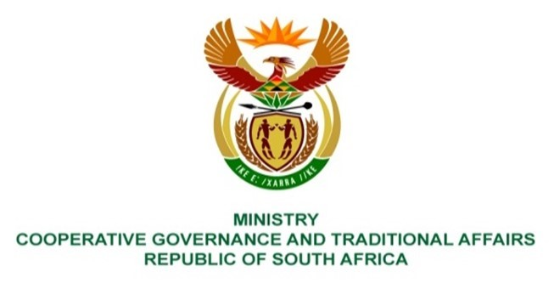
NATIONAL ASSEMBLY
QUESTIONS FOR WRITTEN REPLY
FRIDAY, 27 AUGUST 2021
1939. Mr K Ceza (EFF) to ask the Minister of Cooperative Governance and Traditional Affairs:
- Whether she has been informed of the reasons that the community of Lower Zingcuka, Keiskammahoek, in Ward 11, Amahlathi Local Municipality has been without water for the past 12 months; if not, why not; if so,
- whether she has taken any steps to ensure that there is water in the taps in the specified community; if not, what are the reasons that no steps were taken; if so, by what date will the taps have water again?
REPLY: The information below was sourced from the Provincial department and the District municipality in question
- Amatole District Municipality (ADM) is the Water Services Authority (WSA) in the
ADM area of jurisdiction which includes Amahlathi Local Municipality ALM). The Water Sevices Act, 108 of 1997 defines a WSA as any municipality responsible for ensuring access to water services. According to ADM, the aging infrastructure resulting in ongoing bursts and continuous vandalism of Water Treatment Works are the main contributors leading to unreliable and intermittent supply to Lower Zingcuka.

- According to ADM, water is being carted to Lower Zingcuka to ensure communities get supply. As part of ongoing operations and maintenance, ADM procure and fit necessary fittings and piping to replace burst sections. ADM is currently implementing a Municipal Infrastructure Grant (MIG) funded water supply project with a budget of R5,7 million in the Zingcuka Village. The municipality is awaiting for Eskom connection for the project booster pump which application was submitted. Payments have been made to Eskom and the project is scheduled to be completed by December 2021.
In June 2021, the State of Local Government Report was presented to Cabinet. Cabinet resolved that the Department of Cooperative Governance and Traditional Affairs (COGTA) and National Treasury should lead the process of the development of the municipal support plans in collaboration with sector departments, SALGA, provinces and municipalities. This process is underway and the target date to complete the municipal intervention and support plans (MISP) for high priority municipalities, which include ADM and ALM, is the end of September 2021. This MISP will include plans to address the water challenges mentioned above.

