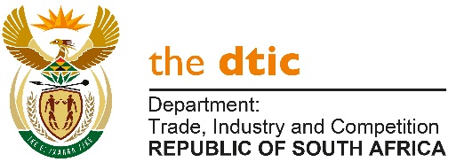

THE NATIONAL ASSEMBLY

QUESTION FOR WRITTEN REPLY

QUESTION NO. 1938

DATE PUBLISHED: 27 AUGUST 2021

Mrs Y N Yako (EFF) to ask the Minister of Trade, Industry and Competition:

What total number of the businesses that supply (a) chicken, (b) rice and/or (c) car accessories in the Republic are South African-owned? [NW2170E]

REPLY:
- The Department does not keep a register of all chicken suppliers. According to SA Poultry, there are 1 117 chicken and egg suppliers in South Africa, the vast majority of which would be South African owned.

(b) The Department does not keep a register of rice suppliers.

(c) It is not clear whether the question on car accessories is intended to refer to items that are solely ‘accessories’ i.e. dash covers, mirrors, car seat covers, phone mounts etc, for which details are not kept; or whether it covers auto components too. The Department has furnished me with the number of local component manufacturers they are aware of – once the question is clarified, the number can be provided.

-END-

