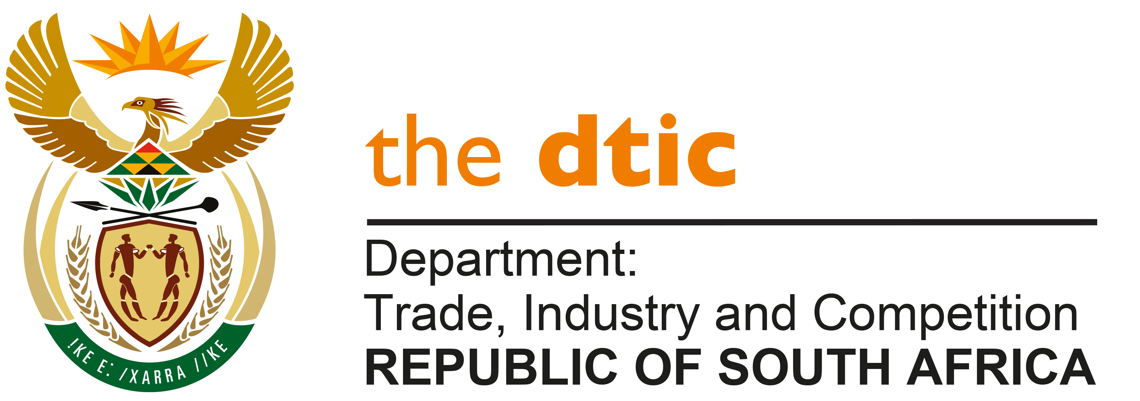

THE NATIONAL ASSEMBLY

QUESTION FOR WRITTEN REPLY

QUESTION 1937

DATE PUBLISHED: 27 AUGUST 2021

Mrs Y N Yako (EFF) to ask the Minister of Trade, Industry and Competition:
What (a) relief measures has he put in place to assist black-owned small businesses and emerging industrialists who lost their properties during the recent unrest in (i) KwaZulu-Natal and (ii) Gauteng, (b) total number of the specified businesses were funded by the Industrial Development Corporation (IDC) and (c) steps has the IDC taken to ensure that the businesses are able to operate again? NW2169E

REPLY

The DTIC, together with the IDC and NEF developed a relief package for businesses covered by the recent unrest in parts of KZN and Gauteng and full details of the measures were made public shortly after they were finalised and further details were subsequently provided to Parliament through the Portfolio Committee on Trade and Industry, on 24 August 2021.

Funding was reprioritised from the budgets of the three entities and this was further supplemented by a fiscal transfer from the National Treasury. The components of the funding covered ddifferent kind of support, often as a ‘blended’ product comprising:
- Grants: this portion is not repayable and is normally granted based on need or developmental objectives being achieved
- Loans: granted at concessionary terms and it is typically for working capital, machinery, repairs to premises, fitment replacement, etc.
- Bridging finance: covers ‘cash-flow’ challenges until SASRIA payouts are made.
The Critical Infrastructure Reconstruction Programme aims to leverage investment by supporting damaged infrastructure. This is a cost-sharing grant of 50% of the total qualifying infrastructure costs with a maximum cap of R30 million.

The Manufacturing Competitiveness Enhancement Programme (MCEP) Economic Stabilisation Fund that provides funding to companies affected by the unrest and associated supply chain disruptions. This will be achieved through financing uninsured businesses not covered by insurance or those with funding insurance shortfalls. The fund offers concessionary funding through interest-free loans with a maximum investment of R50 million.

The NEF Economic Recovery Fund supports affected businesses in all sectors of the economy focused on manufacturing, retail and services businesses. The support targets building improvements and fittings for premises, replacement of machinery, equipment, commercial vehicles and replenishing stock and working capital shortfalls owing to supply chain disruptions. A maximum of R10 million in loan funding will be provided.

In particular, IDC Support Package totalling R1.5 billion from its own balance sheet, made up of R800 million developmental grants and R700 million concessionary loans. To focus the implementation efforts on the delivery of this package, the following essential institutional arrangements were put in place:
- Refined investment guidelines and simplified evaluation process.
- Multidisciplinary deal teams including Business Development Managers, Risk Analysts, and Legal Advisors who meet daily to drive transaction delivery.

Applications are approved by a special Exco committee, composed of IDC Divisional Executives and Senior Professionals, which meets daily.

IDC is also administering the dtic’s R400-million Manufacturing Competitiveness Enhancement Programme (MCEP) Economic Stabilisation Fund that supports manufacturing companies affected, including those impacted by supply chain disruptions. Fund offers concessionary funding through interest-free loans.
The IDC is participating in physical visits to the affected companies. Together with the dtic the IDC is conducting coordinated publicity events to ensure that the funding packages are well advertised to the affected enterprises. This includes roadshows, webinars, virtual and physical site visits to affected clients.

The IDC is also providing Post-funding Business Support to offer non-financial advisory support aimed at restoring the long-term resilience and competitiveness of the affected businesses.

On 24 August 2021, the Department provided information on the approvals made as at that date through the IDC and NEF funding. Since then, a number of further transactions have been approved. The Department will be releasing the updated figures within the next five days and I will provide a copy of the updated data in a supplementary reply.

-END-

