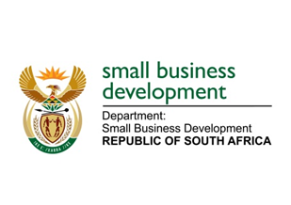
NATIONAL ASSEMBLY

QUESTION FOR WRITTEN REPLY

“1937. Mr T E Mulaudzi (EFF) to ask the Minister of Small Business Development:

(1) What (a) is the total number of incidents of sexual harassment that were reported to the human resources offices of (i) her department and (ii) entities reporting to her in (aa) 2016 and (bb) 2017 and (b) are the details of each incident that took place;
(2) was each incident investigated; if not, why not in each case; if so, what were the outcomes of the investigation in each case?”
NW2094E

REPLY:

(1)(a)(i) The Department of Small Business Development (DSBD)
(aa) 2016/17: Zero.
(bb) 2017/18: Zero.

(1)(a)(ii) Small Enterprise Development Agency (SEDA)
(aa) 2016/17: Zero.
(bb) 2017/18: Zero.

Small Enterprise Finance Agency (SEFA)
(aa) 2016/17: Zero
(bb) 2017/18: 1 incident reported in September 2017.

(1)(i)(b) DSBD: Not applicable.
(1)(ii)(b) SEDA: Not applicable.
SEFA: One alleged case of sexual harassment was lodged. SEFA has a documented process on how to deal with Sexual Harassment matters raised and reported by employees and investigations are in line with the guidelines of the Disciplinary Code and Grievance Procedures approved on 1 October 2016.

(2) DSBD: Not applicable.
SEDA: Not applicable.
SEFA: With regard to the alleged sexual harassment case reported, a due process as per the documented procedure was followed, namely, the investigation, suspension and ultimately employee leaving the employ of SEFA in 2017.

