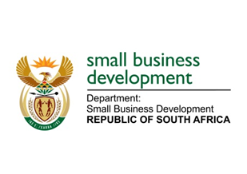
NATIONAL ASSEMBLY
QUESTION FOR WRITTEN REPLY

“1933. Ms B Mathulelwa (EFF) to ask the Minister of Small Business Development:
On what date is it envisaged that she would follow up on the tools of trade that she distributed to informal traders last year in the Eastern Cape?” NW2196E

REPLY:

I have been advised that:
A planned post-investment exercise by the Department of Small Business Development (DSBD) will be undertaken once all the planned handovers for the targeted districts have been concluded. This approach allows for a more comprehensive undertaking that begins to direct government efforts towards Provincial, District and Local Development Plans for the inclusion of supported beneficiaries.

This activity will be tied to programme assessment and the enhancement of the instruments that we develop in response to needs as identified by beneficiaries.

Assessments and post-investment monitoring will be conducted in the Eastern Cape by the department and Seda from the second quarter of the current financial year.

