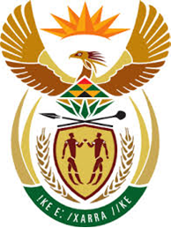

DEPARTMENT: PUBLIC ENTERPRISES
REPUBLIC OF SOUTH AFRICA

NATIONAL ASSEMBLY
QUESTION FOR WRITTEN REPLY
QUESTION 1933

1933. Mr D W Macpherson (DA) to ask the Minister of Public Enterprises:

[Interdepartmentally transferred from the Minister of Trade, Industry and Competition on 21 August 2020]

- By what date is the R3,5 billion loan and/or equity bridge from the Development Bank of South Africa to South African Airways repayable;
- whether the loan will be repaid under the business rescue process; if not, what is the position in this regard; if so, who will be responsible for the repayment of the loan? NW2449E

Reply:
- The loan from the Development Bank of Southern Africa to South African Airways (SAA) was paidON THE DIRECTION OF THE NATIONAL TREASURY,on 27 August 2020.
- The loan was repaid from the 2020 Medium Term Expenditure Framework (MTEF) allocation for the period 2020/21 to 2022/23 financial year, for the purchase of equity in SAA.

