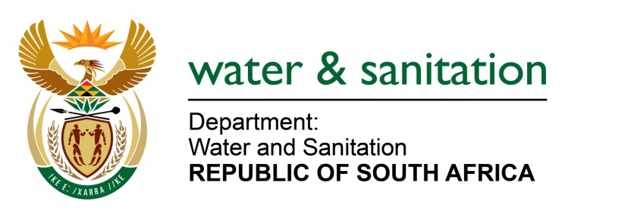

NATIONAL ASSEMBLY

FOR WRITTEN REPLY

QUESTION NO 193

DATE OF PUBLICATION IN INTERNAL QUESTION PAPER: 11 FEBRUARY 2016
(INTERNAL QUESTION PAPER NO. 1)

193. Mr E J Marais (DA) to ask the Minister of Water and Sanitation:
(1) (a) What is her department’s figure for the amount of water that is potentially available for development in the year 2025, or the closest date for which these projections are made and (b) when was this figure calculated;
(2) (a) what are her department’s projections for water demand in 2025 or the closest date for which these projections are made under (i) base scenario and (ii) high scenario, (b) when were these figures calculated and (c) what was the (i) population and (ii) economic growth figures used in these calculations? NW193E
---00O00---

REPLY:

- In the First Edition of the National Water Resource Strategy (NWRS1) of 2004 the total volume of water available from the river systems in South Africa on a reliable basis for 2025 was estimated at 14 166 million m³/a.

- The total water requirements for 2025 base and high scenario was estimated at 14 230 million m³/a and 16 814 million m³/a respectively. The amount of water that could potentially be available for development in the year 2025 was estimated at 5 410 million m³/a. This surplus amount is however only available in some catchments throughout the country. This analysis was done considering a projected population of 54 million and economic growth trends at the time.
---00O00---

