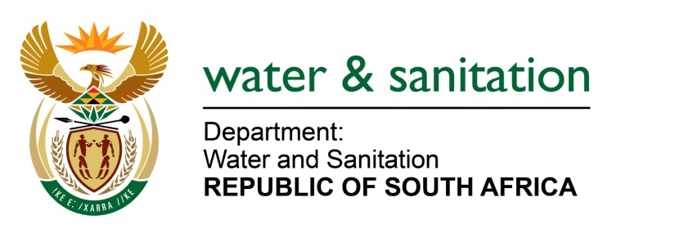

NATIONAL ASSEMBLY

FOR WRITTEN REPLY

QUESTION NO 1928

DATE OF PUBLICATION IN INTERNAL QUESTION PAPER: 19 MAY 2023
(INTERNAL QUESTION PAPER NO. 18)
1928. Mrs M R Mohlala (EFF) to ask the Minister of Water and Sanitation:
What interventions has he taken to address the water crisis in Zakheni Village, Mpumalanga, where some households have been without consistent running water for three years, with some spending hundreds of Rand on water, while the Thembisile Hani Local Municipality battles to find a permanent solution?
NW2189E
---00O00---
MINISTER OF WATER AND SANITATION

The Department of Water and Sanitation (DWS) engaged the Thembisile Local Municipality and they confirmed that the pipeline supplying Zakheni village was damaged by the floods for a period of three (3) to four (4) months which affected water supply. The status is reported as follows:
- The contractor was appointed, and repairs to the damaged pipeline were completed on 30 April 2023.
- Water has been restored in the area and is supplied on rationing scheduling.
- Other areas still receive water through the water tanks to augment the unconnected or unserved areas.
- The municipality is building a new reticulation pipeline.

- The long-term water supply plans for the area are as follows:The Thembisile Hani Local Municipality is supplied by Rand Water and the City of Tshwane based on agreed contracts as it does not have a dedicated water source to supply water to the residents of the municipality. The water supply contracts with Tshwane and Rand Water are under review to increase the current water supply.
- The community of KwaMhlanga and Zakheni will also benefit from the Loskop Bulk water supply scheme once it is completed. The anticipated completion of the project is planned for November 2024.

---00O00---

