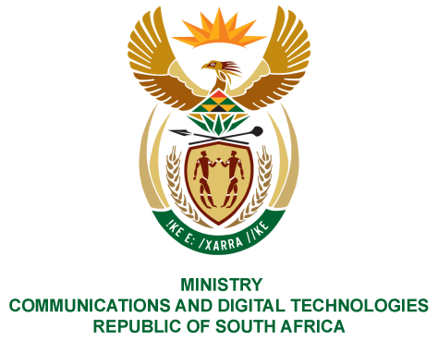
PARLIAMENT OF THE REPUBLIC OF SOUTH AFRICA
NATIONAL ASSEMBLY
WRITTEN REPLY

QUESTION NO: 192
DATE OF PUBLICATION: 01
QUESTION PAPER NO: 11 February 2021
Mrs C Phillips (DA) to ask the Minister of Communications
With reference to her reply to question 2995 on 6 January 2021, what total number of (a) persons paid their TV licences in (i) 2017-18, (ii) 2018-19 and (iii) 2019-20 financial years and (b) accounts were sent out via (i) mail, (ii) sms and (iii) email in each financial year?
NW195E

REPLY:

I have been advised by the SABC as follows:
(a)
Financial Year | Business Licence | Dealer Licence | Concessionary Licence | Domestic (Normal) | Total
2017 - 2018 | 37 003 | 4 079 | 514 653 | 2 181 630 | 2 737 365
2018 - 2019 | 36 400 | 4 007 | 461 621 | 2 265 324 | 2 767 352
2019 - 2020 | 29 522 | 3 418 | 393 963 | 1 896 586 | 2 323 489

(b)

Financial Year | E-mails | SMS | Mailed letters
2017 - 2018 | 23 846 458 | 103 909 803 | 372
2018 - 2019 | 23 793 849 | 82 655 991 | 0
2019 - 2020 | 8 025 851 | 28 055 096 | 0

MS. STELLA NDABENI-ABRAHAMS, MP
MINISTER OF COMMUNICATIONS AND DIGITAL TECHNOLOGIES

