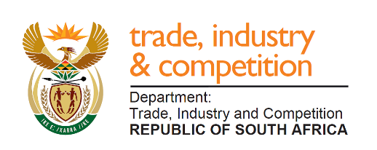

THE NATIONAL ASSEMBLY

QUESTION FOR WRITTEN REPLY

QUESTION 192

Mr. T.W Mhlongo (DA) to ask the Minister of Trade and Industry:

- How does the National Lotteries Commission (NLC) intend to support the South African athletes who will be participating in the Olympics in Birmingham in Alabama, United States, in 2021, given the financial challenges faced by the SA Sports Confederation and Olympic Committee and (b) what is the role of the NLC in promoting women sport in the Republic through its funding? NW213E

REPLY

I am advised by the NLC that applications for participation in the 2021 Olympics in Birmingham in Alabama, United States, have not been made. All applications received will be considered.
The Sports and Recreation Distributing Agency approved funding for the following women sporting codes in the current financial year (2019/20) - soccer R8 Million (South African Football Association), cricket R1 Million (Cricket South Africa), swimming R2 Million (Swimming South Africa).

-END-

