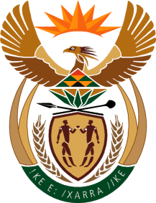

MINISTRY OF TOURISM
REPUBLIC OF SOUTH AFRICA

Private Bag X424, Pretoria, 0001, South Africa. Tel. (+27 12) 444 6780, Fax (+27 12) 444 7027
Private Bag X9154, Cape Town, 8000, South Africa. Tel. (+27 21) 469 5800, Fax: (+27 21) 465 3216

Ref: TM 2/1/1/10

QUESTION FOR WRITTEN REPLY:
Question Number: 192
Date of Publication: 17 February 2017
NA IQP Number: 2
Date of reply: 9 March 2017

Mr B R Topham (DA) to ask the Minister of Tourism:
(1) Whether, with reference to the National Tourism Strategy, any progress has been made in identifying municipal and other government-owned resorts and properties that are not being optimally used or under-utilised; if not, why not; if so, what are the relevant details;
(2) what are the relevant details of the specified projects for each of the past three financial years? NW203E

Reply:
- The audit that the Department conducted in partnership with the Industrial Development Corporation (IDC) provided a baseline of municipal and provincially owned tourism assets. This report was made available to all provinces for project and budget planning purposes

- The Department of Tourism has not support any project based on the outcomes of the report as yet. However, province would in a better position to share further detailed information regarding their respective tourism assets.

