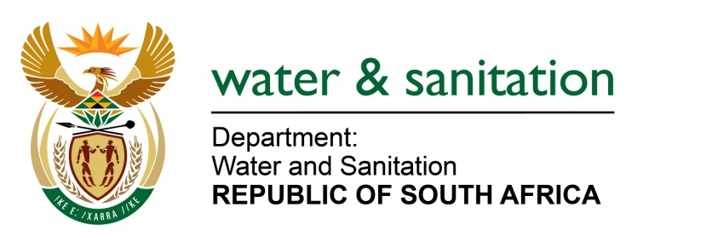

NATIONAL ASSEMBLY

FOR WRITTEN REPLY

QUESTION NO 192

DATE OF PUBLICATION IN INTERNAL QUESTION PAPER: 11 FEBRUARY 2016
(INTERNAL QUESTION PAPER NO. 1)

192. Mr E J Marais (DA) to ask the Minister of Water and Sanitation:
(1) With reference to her reply to question 570 for oral reply on 11 November 2015, what are the results of the latest E.coli tests done by her department in the (a) Apies River and (b) adjacent boreholes;
(2) on what date was the City of Tshwane requested to provide her department with an action plan detailing how it will deal with Rooiwal Power Station;
(3) whether she has received the specified action plan from the City of Tshwane; if not, when is the action plan due; if so, will she provide Mr E J Marais with the action plan;
(4) (a) what alternative action does her department pursue when it is satisfied that it has exhausted the recourse provided by the Inter-governmental Relations Framework Act, Act 13 of 2005 and (b) in terms of what legislation and/or regulations is this action pursued,
(5) whether she has employed the specified alternative course of action; if not, why not; if so, what are the relevant details? NW192E
---00O00---
REPLY:
(1)(a) The latest results available for E coli for Apies River reveal medium to low risk. This can be attributed to the improvement made at the Rooiwal waste water treatment plant since my Department’s intervention.

(1)(b) Tests conducted in adjacent boreholes revealed low to medium risk levels of E-coli found.
(2) The action plan was requested for end of August 2015.
(3) Yes. The action plan was submitted on 31 August 2015. A copy of the action plan is attached. It must be noted that the action plan is a living document and it is revised as and when required.
(4)(a) If all avenues provided for by the Inter- governmental relations framework Act, Act 13 of 20015 has been exhausted and no noticeable improvement can be observed, Criminal Charges are laid against the relevant organ of state.
(4)(b) These criminal charges are pursued in terms of the National Water Act, 1998 (Act No. 36 of 1998).
(5) No. My Department has not pursued the alternative (criminal charges) thus far. My Department is engaging with the City of Tshwane on the action plan and the last engagement was on 8 December 2015. During the engagement, the City Manager committed R140 000 000 to upgrade the plant. Furthermore, the municipality is currently looking at all legal avenues within the supply chain process (SCM) to fast track the procurement of the contractors to urgently start with the required upgrade. My Department is closely monitoring the SCM process and the development at the woks. The last visit at the plant was on 15 January 2016 and there is promising improvement, within the current treatment capacity.
---00O00---

