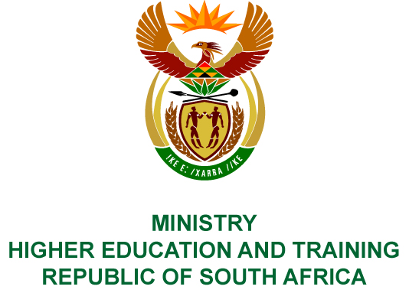
Private Bag X893, Pretoria, 0001, Tel (012) 312 5555, Fax (012) 323 5618
Private Bag X9192, Cape Town, 8000, Tel (021) 469 5150, Fax: (021) 465 7956
Memorandum from the Parliamentary Office
NATIONAL ASSEMBLY
FOR WRITTEN REPLY
QUESTION 1919
DATE OF PUBLICATION OF INTERNAL QUESTION PAPER: 08/06/2018
(INTERNAL QUESTION PAPER NO 20 OF 2018)
Ms N Nolutshungu (EFF) to ask the Minister of Higher Education and Training:
(1) What (a) is the total number of incidents of sexual harassment that were reported to the human resources offices of (i) her department and (ii) entities reporting to her in (aa) 2016 and (bb) 2017 and (b) are the details of each incident that took place;
(2) was each incident investigated; if not, why not in each case; if so, what were the outcomes of the investigation in each case?
NW2076E
REPLY:
- (a) (i) None.
(ii) The number of sexual harassment incidents that were reported to the Human Resources section of Technical and Vocational Education and Training (TVET) colleges:
(aa) In 2016, 7 incidents.
(bb) In 2017, 0 incidents.
The information related to public universities are being collected and will be made available once collated.
Sector Education and Training Authorities reported no sexual harassment incidents for the periods in question.
- In relation to the incidents reported to the Human Resources section of TVET colleges:
- The South West Gauteng TVET College incident was investigated, and a disciplinary hearing against the official was instituted, which resulted in a guilty verdict with a sanction of dismissal on 19 October 2016.
- The Tshwane North TVET College incident was investigated, and a disciplinary hearing against the official was instituted. The official resigned on 24 June 2016 before the commencement of the disciplinary hearing.
- The South West Gauteng TVET College incident was investigated, and a disciplinary hearing against the official was instituted, which resulted in a guilty verdict with a sanction of dismissal on 20 May 2016. The official filed a notice to appeal and the Appeal Committee on 08 December 2016 upheld the sanction of dismissal.
- The Umfolozi TVET College incident was investigated, but the official withdrew the allegation on 23 January 2017.
- The False Bay TVET College incident was investigated, and a disciplinary hearing against the official was instituted, which resulted in a guilty verdict with a sanction of a final written warning on 15 December 2016.
- The Buffalo City TVET College incident was investigated, and a disciplinary hearing against the official was instituted, which resulted in a guilty verdict with a sanction of dismissal on 19 September 2016.
- The Vhembe TVET College incident was investigated, and a disciplinary hearing against the official was instituted, which resulted in a guilty verdict with a sanction of 3 months without pay and a final written warning on 2 December 2016.

