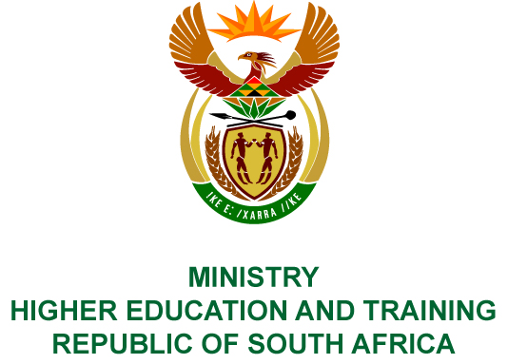
Private Bag X893, Pretoria, 0001, Tel (012) 312 5555, Fax (012) 323 5618
Private Bag X9192, Cape Town, 8000, Tel (021) 469 5150, Fax: (021) 465 7956
Memorandum from the Parliamentary Office
NATIONAL ASSEMBLY
FOR WRITTEN REPLY
QUESTION 1915
DATE OF PUBLICATION OF INTERNAL QUESTION PAPER: 23/06/2017

(INTERNAL QUESTION PAPER 23 OF 2017)
Mr D America (DA) to ask the Minister of Higher Education and Training:
Has his department taken any steps to ensure that the curriculum for technical and vocational education and training colleges is modernised according to 21st century imperatives; if not, why not; if so, what are the relevant details?
NW2127E

REPLY:
There are currently three qualification types offered in the Technical and Vocational Education and Training (TVET) sector.
National Curriculum Vocational (NC(V))
Thirteen NC(V) programmes were initially developed in 2005 and 2006. Implementation of these programmes started in January 2007 for the first time in TVET colleges. Since then, additional NC(V) programmes and subjects have been developed; a total number of 19 different NC(V) programmes are offered in TVET colleges in 2017.
The difference between the NC(V) programmes and the legacy programmes is the inclusion of three compulsory fundamental subjects – a language, mathematics or mathematical literacy as well as life skills and computer skills to address numeracy, literacy, life and computer skills.
Within each one of the programmes there are three compulsory subjects dealing with the core nature of the subfield within which the programme has been developed plus one subject of choice intended to become a specialisation, e.g. welding, plumbing, fitting and turning.
The Chief Directorate: Programmes and Qualifications undertakes the revision of identified NC(V) subject curricula/syllabi whenever gaps are identified, with available resources.
Examples of subjects where these revisions were done are:
- Welding;
- Automotive Repair and Maintenance;
- Information Processing plus; and
- Fundamental subjects – language, mathematics, mathematical literacy, life skills and computer skills.
Examples of additional programmes developed and implemented in 2007 are the following:
- Transport and Logistics;
- Safety in Society; and
- Primary Health Care.
Examples of additional optional subjects developed and implemented are:
- Renewable energy technology;
- Multimedia;
- Graphic Design; and
- Wholesale and Retail.
Umalusi is currently concluding the comprehensive review of the NC(V) policy. Once this is done, a full-scale review of all programmes, the National Qualifications Framework level as well as the detailed subject curricula will be done.
NATED / REPORT 191 programmes
The NATED/Report 191 programmes were intended to be phased out with the implementation of the NC(V) programmes. However, different stakeholders and role players expressed the need for these programmes to continue despite the introduction of the NC(V) programmes. This programme was re-introduced in 2009 based on industry demand.
A total number of 8 subjects were reviewed to mainly accommodate changes in legislation and some changes in industry practices, e.g. in the tourism industry. The revision and reworking of these subject curricula happened under the authority of the Quality Council for Trades and Occupations (QCTO). The specific subject curriculums revised in 2012 for immediate implementation in the following year were:
- Labour Relations N5 and N6;
- Financial Accounting N6;
- Mercantile Law N4 and N5;
- Travel Service Procedures N4; and
- Municipal Administration N5 and N6.
At present all N4 –N6 programmes are being reviewed by QCTO. Upon completion of the review, systematic “syllabus development” will be undertaken.
Occupational Programmes
The occupational programmes developed by QCTO are some of the most modern and industry relevant. There has not been wide scale implementation in colleges. The Department is currently working on the delivery methodology of these programmes through a number of pilot programmes. In this financial year, the Department aims to develop 13 sets of curricula/syllabi for the trade qualifications for implementation in 2019.
The Department is in the process of establishing a unit to fulfil the functions of the South African Institute for Vocational and Continuing Education and Training (SAIVCET). In the White Paper for Post-School Education and Training, it is anticipated that this unit should be a separate public entity. As there is no fiscal funding available for this unit, it will therefore be funded by the National Skills Fund up until 2021. SAIVCET as one of its first tasks has developed a comprehensive curriculum review plan for the next five years.

COMPILER/CONTACT PERSONS: Ms G Magnus
EXT: 5755

DIRECTOR – GENERAL
STATUS:
DATE:

QUESTION 1915 APPROVED/NOT APPROVED/AMENDED

Dr BE NZIMANDE, MP
MINISTER OF HIGHER EDUCATION AND TRAINING
STATUS:
DATE:

