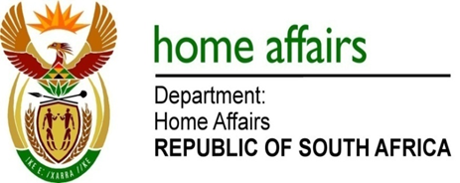

NATIONAL ASSEMBLY

QUESTION FOR WRITTEN REPLY

QUESTION NO. 1913

DATE OF PUBLICATION: FRIDAY, 8 JUNE 2018

INTERNAL QUESTION PAPER 20 OF 2018

1913. Mrs H O Mkhaliphi (EFF) to ask the Minister of Home Affairs:

(1) What (a) is the total number of incidents of sexual harassment that were reported to the human resources offices of (i) his department and (ii) entities reporting to him in (aa) 2016 and (bb) 2017 and (b) are the details of each incident that took place;
(2) was each incident investigated; if not, why not in each case; if so, what were the outcomes of the investigation in each case? NW2070E

REPLY:

The Department and entities responded as follows:

- Department of Home Affairs
(1)(a)(aa) One
(1)(a)(bb) One

(1)(b) 2016
- The case involved a female foreign national (the complainant) and an immigration officer at level 8 (the alleged perpetrator). Charges of misconduct were preferred against the Officer and a disciplinary hearing was held. The Officer was found guilty and a sanction of dismissal was pronounced by the chairperson of the disciplinary hearing. The dismissal was implemented. From the employee side the matter have been taken for review of the decision of the presiding officer.
- The employee took the matter to the Labour Court for review – the case is still pending.

(1)(b) 2017
- This case was registered as a grievance but the case was investigated and an outcome was issued. The employee consequently registered a dispute with CCMA based on sexual harassment. The Commissioner ruled that the employee must be compensated for sexual harassment. The department implemented the sanction and the employee was compensated.
- The case is completed and concluded - closed.

(2) Yes. The outcomes of the two cases investigated are detailed in (1)(b) above.

(ii) Electoral Commission
(1)(a)(aa) None
(1)(a)(bb) None

(1)(b) Not applicable

(2) Not applicable

(ii) Government Printing Works
(1)(a) (aa) None
(1)(a)(bb) One

(1)(b) There was an allegation of unacceptable utterances (sexual comments) reported.

(2) Yes. The employee was given verbal warning.

